THE USE OF MIND MAPPING PICTURE TO IMPROVE STUDENTS’ WRITING SKILL
OF DESCRIPTIVE TEXT AT GRADE VIII OF SMP S JOHAN SENTOSA

DEBI EKA SUKMA
debbyjustyes@gmail.com

GUSPARIA
guspariaemzet@gmail.com

STKIP INSAN MADANI AIRMOLEK

ABSTRACT

The purpose of this research are to find out the extent to what mind mapping picture improves students’ writing skill of descriptive text at grade VIII of Johan Sentosa and to find out the factors that influence the changes of students’ writing skill of descriptive text by using mind mapping picture at grade VIII of SMP S Johan Sentosa. The kind of this research is Classroom Action Research (CAR). It was started from May 10th 2017 up to June 15 ^{th} 2017. The research was conducted in three cycles, which each cycle had four meeting. The population in this research were 32 students. The researcher gathered the data in each cycle from observation checklist, fieldnotes, interviews and writing test.
After analyzing the data, the researcher found that mind mapping picture was able to improve the students’ writing skill in describing an object. Based on the result in test I is 60,38 then the result of the test II is 71,13 and the result of test III is 77,50, it could be seen that there were improvement in students’ writing. So, the using of Mind Mapping Picture can improve the students’ writing skill on descriptive text at grade VIII of SMP S Johan Sentosa PT.KAT-Kelesa. Furthermore, the factors that influenced the improvement of students’ writing involved media and material. Finally, the implementation of mind mapping picture in teaching writing of descriptive text could provide satisfied result on students’ writing skill.

Key Words: Improve, Writing Skill, Mind Mapping Picture, Descriptive Text

INTRODUCTION
Writing is a productive skill that is communicated by using written form. Writing is a language skill that is used to communicate indirectly, not face to face with others. According to Florian Coulmas (2003: 3), he distinguished six meaning of writing, namely : (1) a system recording language by means of visible or tactile marks; (2) the activity of putting such a system to use; (3) the result of such activity a text; (4) the particular form of such a result, a script style such as block letter writing; (5) artistic composition; (6) a professional occupation. Writing is productive and expressive activity .Based on explanation above, a writer must master graphology, language, structure and vocabulary, because writing skill will not come automatically, but it must be through practice regularly.
To write English well, the students should master all components of writing skill, namely grammar, vocabulary, content/ideas, mechanics, and organization. Through writing, the students can restate information that he understands from texts or articles as well as information that he listens to. Moreover, it is also a very useful language skill to deliver information through written communication. It is in line with Hughes (2003 : 101-102) points out five indicators of a good writing. The first indicator is grammar (language usage). In writing the use of grammar must be used correctly based on writing context. Secondly, vocabulary, the ability in choosing appropriate vocabulary in writing is strongly important, since it helps a writer write well. Next, it is mechanics. Mechanics cover several points such as punctuation, spelling and capitalization. It helps the reader in understanding the content of the composition easily. Then it is fluency (style and easy of communication). A paragraph is stated as fluent when the choice of the structure and vocabulary are consistently appropriate in order easily to be comprehended. Finally is organization (form), which is essential for a paragraph to have form (organization), which means that all the sentences in the paragraph discuss only one main idea.
At SMP/MTS level, students must be able to write several kinds of text in the form of paragraphs, the example of text are narrative, recount, procedure, and descriptive. To reach this goal, students must be able to produce a writing product. As educator we must be able to build interest in their learning especially in writing English paragraph.
Descriptive text is chosen by the researcher in conducting this research. . It is a kind of text, which function is to describe something or an object which lead to points to be described in specifically. Alice Oshima and Ann Hogue (2007: 61) states that “Descriptive is tells how something looks, feels, smells, tastes or sounds.” It means that the students will write based on they looks, feels, smells, tastes or sounds that they learned by they own language. Moreover, Dorothy (2003: 88) states “descriptive is explains how someone or something looks or feels. In additional, Alice (2007: 58) states that “descriptive text describes a person, place or thing so that the reader can picture it in his or her mind”. From explanation above it can be concluded that the descriptive text is a type of text that describes something, whether it be things, animals, places, plants or whatever it is expected that something becomes clear and specific.
To help students writing descriptive text, the teacher has to help his / her students in writing. Aiex (2008: 25) defines “media as a device used by teacher in teaching-learning process that makes learners understands the material given”. Media provide an excellent source for discovering a “new” place and make students competent more culturally. In addition, Sharon et al (2007: 6) define “media, the plural of medium, are means of communication”. The term refers to “anything that carries information between a source and a receiver”. Referring to those definitions, the researcher can conclude that media is related in communication and learning to transfer or deliver messages and it designed by the teacher which should be enjoyable and meaningful for the students. There are many kinds of media that can be used for the teacher in helping the students, such as visual, audio, and audio-visual. Therefore, in order to help the students, the use of media is important.
Here, the researcher chooses one kind of visual media to help the students in learning writing – that is, mind mapping picture. Mind mapping is one of strategy that used by many teachers in writing skill because, it can help students in ingenerating an idea. According to Riswanto and Pebri (2012: 4), Mind mapping is “a graphic representation of ideas (usually generated via a brainstorming session)”. It shows the ideas which are generated around a central theme and how they are interlinked. Meanwhile, Tony Buzan (2005;4) stated “a mind map is an easy way to get information into and out of your brain”. In addition, Syeda (2016: 62) stated that “mind mapping is the eases way to develop information in human mind and take information from out of brain”. It is a created and effective way that made our ideas. Maps are easier to follow than the long note taking or listing techniques where ideas are kept in a top down sequence and it becomes difficult to make connection of the last idea to the first in the list. Mind maps can work as tool to facilitate the learners to plan ideas especially in the pre-writing process. In line with definition mapping map in previous paragraph, it is clear that mapping map is a useful strategy in pre-writing process. Learners will provides some ideas to start writing.
Based on the explanation above, the researcher was interest to apply Mind Mapping Picture in teaching writing. By carrying out this research, the researcher expected that the implementation of Mind Mapping Picture in teaching writing Descriptive text probably helps students to overcome their difficulties in writing and to achieve the improvement of their writing skill.
Furthermore, there are many factors that influence students in learning writing. Myles (2002: 5) points out “two factors influence students writing ability; social factors and cognitive factors”. Social Factor covers learner attitudes and learner motivation. Teachers should be able to motivate students in writing task and develop positive attitude which can have a positive effect on their writing. On the other hand, cognitive factors related to how learners use their language in writing. It can be thought that writing in a second language is a complex process involving the ability to communicate in L2 (learner output) and the ability to construct a text in order to express one’s ideas effectively in writing. Vocabulary and language transfer are considered difficult for almost students. In order to have an effective writing teacher must concern this factor when teaching writing.
Based on the explanation above, the purposes of this research are (1) to find out the extent to what mind mapping picture can improve students’ writing skill of descriptive text at grade VIII of SMP S Johan Sentosa and (2) to find out the factors that influence the changes of students’ writing skill of descriptive text by using mind mapping piture at grade VIII of SMP S Johan Sentosa.

METHOD
This research was a classroom action research. According to Gay and Airasian (2000:593), “classroom action research is a process in which individual or several teachers collect evidence and make of their knowledge, performance, and effects in order to understand and improve their teaching activities in classroom”. In addition, Zainil (2008:1) defines that “classroom action research is a research that conducted by teachers as researcher which collaborate with collaborator in order to improve the teaching and learning process of their own classroom”.
This research was conducted to improve the students’ writing skill in describing an object at grade VIII of SMP S Johan Sentosa by using mind mapping picture. This research was done in two cycles in cyclic process which involved four steps for one cycle. It was done by admitting the model that is suggested by Kemmis and McTaggart in Burns (2010:9). They propose “the model of classroom action research which involves planning, action, observation and reflection”. The researcher worked collaboratively with other English teacher to get better result.
This research was conducted at class VIII of SMP S Johan Sentosa which was located in PT.KAT-Kelesa, sub district of Indragiri Hulu. The participants were students at class VIII SMP S Johan Sentosa PT.KAT-Kelesa 2017/2018 Academic year consisting of 32 students. There were four instruments in this research; writing test, observation checklist, field notes and interview. The data were analyzed quantitatively and qualitatively.

RESEARCH FINDINGS
The improvement of students’ writing score is the main indicator of the success in using mind mapping pictures. In the first writing test in Cycle I, the result of the test showed that the average score of each writing indicators are higher than basic score. They could achieve an improvement from one meeting to other meetings. The score started on grammar 42.38 in the first meeting of cycle 1. Then, it improved throughout the meetings. Finally, in test 1 the score of the students’ skill in writing descriptive text could reach 60.38. The score indicated that the students’ are able to write descriptive text by using animation video. However, the average score for cycle 1 was still 60. Therefore more treatment in cycle two was needed to improve the score.
The improvement of students’ writing skill could be seen by the result of the students’ writing test in the following graph:

Graph 1: The Improvement of Students’ Mean Score per Indicator of writing Test 1 and test 1 at the end of cycle 1

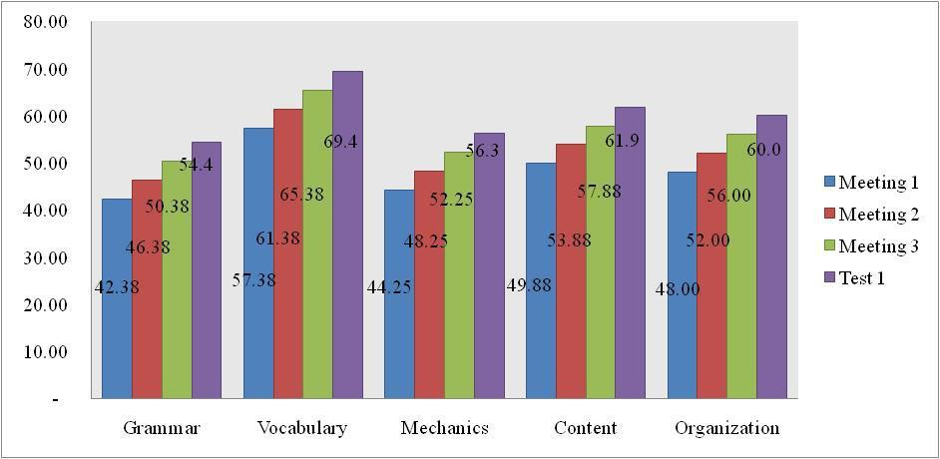

From the graph, it was clear that after implementation of mind mapping pictures in teaching writing descriptive text, the students’ writing skill improved for all of indicators of writing skill. It was be referred by their mean score on test 1 at the end of cycle 1 after implementation of mind mapping pictures was higher than their mean score before implementation mind mapping pictures. All indicators were still unsatisfied. They were lower than the criteria standard achievement, namely 74. It indicate that the students’ writing skill still low or on fair level.
From description above, some plans should be arranged as reflection of the activities in order to have more improvement of the students’ writing skill. Some problems were still found in implementing the students’ activities through mind mapping picture in the first cycle. First, students paid less attention to the teacher's explanation, making it unclear to them. Second, the topic was given must be better known by the students in order to get a better idea and easy in writing. Last, students still had problems in grammar, vocabulary, content, and organization.
As a result, the revise plan on Cycle II was better to improve the students’ writing skill of descriptive text related to all writing skill indicators.
The improvement of students’ writing skill could be seen by the result of the students’ writing test in the following graph:

Graph 2: The Improvement of Students’ Mean Score per Indicator of Writing Skill on Test 2 at the end of cycle 2

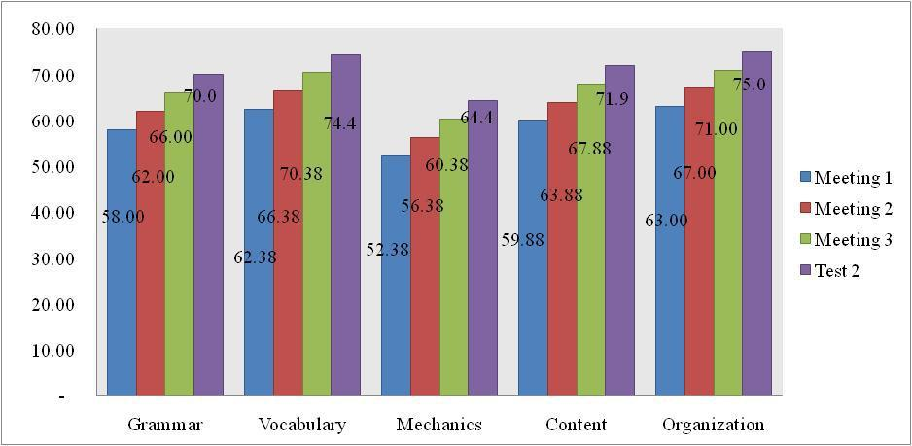

From the graph, it was clear that after implementation of mind mapping pictures in teaching writing in cycle 2, the students’ writing skill was still low for all of indicators of writing skill. In this cycle, the students’ mean score of the students’ writing was 70. Based on the data in first cycle and second, it was found that the students’ mean score were not satisfied enough. Therefore it is necessary to continue to the third cycle. It focuses to improve students’ grammar, content and organization, discusses vocabularies, monitors and assists while writing.

Graph 3: The Improvement of Students’ Mean Score per Indicator of Writing Skill on Test 3 at the end of cycle 3.
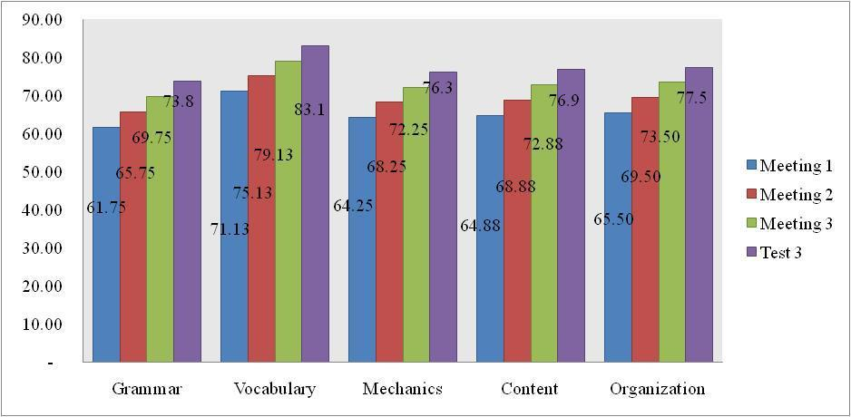

The graph above shows the quantitative data of the students writing skill improvement in third cycle. It is illustrated that their writing proficiency improved significantly, which could be seen from the increasing of average score in each writing indicator. In the end of the cycle, they achieved mean score that is 83 in vocabulary aspect. It indicated that average score is higher than the minimum Standard of achievement of students’ writing descriptive text.
After the improvement of students during the three meetings, the researcher tested the students’ writing skill on descriptive text at the end of the third cycle. The result of students in these tests was satisfactorily, because students can achieve an average score that is higher than the minimum completeness criteria that is 77.5. It can be concluded that they could improve their writing ability by using mind mapping picture. The use of picture on this research can help students to increase the value of the indicator writing In other words, mind mapping pictures as a media is effective for the results of the students' writing skill. Lastly, it can be categorized a successful research.
It was also referred by the data from observation checklist and field note, the researcher found that the activities in using mind mapping pictures provided positive contributions on the students’ writing skill improvement. Those data, qualitative and quantitative, were enough prove that the process that brought in the teaching and learning process was active in solving the students’ writing problems. The process covered encouraging the students’ vocabularies, discussing and assisting the students while doing writing.

The improvement of students’ writing skill is influenced by several factors. It can be revealed from observation checklist, field note and interview. The factors are material, media, amount of practice and teacher’s approach and students’ interaction. In line with those factors above, the researcher did the research through the better approach. She taught descriptive texts and discussed the vocabularies before students writing. Then, she monitors and assists the students while doing writing a descriptive text. She also discusses the students’ mistake each meeting in order to improve the students’ writing skill for the next meeting.

CONCLUSION AND SUGGESTIONS
After carrying out this classroom action research in the third cycles, it can be concluded that mind mapping pictures had successfully improved the students’ writing skill of descriptive text by using mind mapping pictures at texts at grade VIII of SMP S Johan Sentosa to the writing skill indicators. It is supported by quantitative data which showed the improvement of students’ writing skill in each indicator; grammar, vocabulary, mechanics, content and organization, as well as their mean score in basic score, writing test in first cycle, test in cycle 2 and test in cycle 3. The average of students’ score in basic score was only 48, in cycle 1 the average score increased become 60.38, in cycle II was become 71.13 and in cycle III increased become 77.50. It means that the students’ average score in cycle III could reach the minimum criteria of achievement of English subject at SMP S Johan Sentosa that is 74.
The successful of mind mapping pictures in improving the students’ writing skill was influenced by some factors. They are materials, media, teacher’s approach, amount of practice and students’ interaction. In line with those factors above, the researcher did the research through the better approach. She teaches narrative texts and discusses the vocabularies before students writing. Then, she monitors and assists the students while doing writing a narrative text. She also discusses the students’ mistake each meeting in order to improve the students’ writing skill for the next meeting.
Based on the findings, some suggestions are given to English teachers and further researchers. Since the mind mapping pictures can help the students’ writing skill, it is recommended that English teachers incorporate the use of mind mapping in the classroom. The teachers have to select the mind mapping pictures based on the criteria that have been discussed before. The mind mapping pictures can also be used in teaching other skills such as speaking and vocabulary. The research can also serve as a reference for researchers to conduct further research. The mind mapping pictures can be employed to teach other topics or text types and other language skills. Finally, since this media can be used by the students independently, the researcher suggests that students to use the mind mapping pictures as alternative media for writing class to help them to improve their writing skill.

REFERENCES
Aiex, N.K. 2008. Media use in the classroom. Bloomington: ERIC Clearinghouse on Reading and Communication Skills.

Alice Oshima, Ann Hogue. 2007. Introduction to Academic Writing, third edition. New York: Longman.
Burns, Anne, 2010. Doing Action Research in English Language Teaching: A Guide for Practitioners. Routledge: ESL & Applied Linguistics Professional Series.

Dorothy, E Zemark and Lisa A Rumisek.2003. Academic Writing from Paragraph to essay. Oxford: Macmillan Education
Florian, Coulmas. 2003. Writing Systems An introduction to their linguistic analysis. New York: Cambridge University Press
Gay. L. R and Peter Airasian. 2000. Education Research: Competencies for Analysing and Application (6thed). Saddle River, New Jersey :Pretice Hall.

Hughes, Arthur. 2003. Testing for Language Teachers. NY: Cambridge University Press.
Myles, J. 2002. Second Language Writing and Research: The Writing Process and Error Analysis in Student Texts. TESL-EJ, 6(2), 1-9.

Sharon, F, et al. 2007. Instructional Technology and Media for Learning. Upper Saddle, NJ: Prentice Hall.

Riswanto dan Pebri Prandika Putra. 2012. The Use Of Mind Mapping Strategy in the Teaching of Writing at SMAN 3 Bengkulu, Indonesia. International Journal of Humanities and Social Science. Vol 2 No.21
Suyanto, Adi. 2015. The Effectiveness Of Mind Mapping In Improving Students’ Writing Skill Viewed From Their IQ. IJEE(Indonesian Journal of English Education). 2 (2) 2015. 101-119.
Syeda Saima, Bukhari. 2016. Mind Mapping Techniques to Enhance EFL Writing Skill. International Journal of Linguistics and Comminication. June 2016, vol. 4, No 1, pp. 58-77.

Tony Buzan. 2007. Mind Maps for Kid. Jakarta: PT Gramedia Pustaka Utama.

Zainil. 2008. Actional Functional Model (AFM). Padang: Sukabina Offset.

