STUDENTS’ PERCEPTION OF USING PADLET IN LEARNING ENGLISH AT THE FIRST SEMESTER OF ISLAMIC EDUCATION DEPARTMENT STAI HUBBULWATHAN DURI
Setiawati, M.Pd
Setiacantik85@gmail.com
STAI HubbulwathanDuri

Abstract: This study aimed to know students’ perception of using padlet in learning English at the first semester of Islamic Education Department STAI Hubbulwathan Duri. This research used quantitative approach. The design of research was survey. This research, the writer conducted descriptive survey. Total population was the first semester of Islamic education STAI Hubbulwathan Duri. The undergraduate students have the same qualification and academic background before doing survey. They had ever learned English by using Padlet. Sample of this research was 61 respondents. Total rating percentage of students’ perception using Padlet in learning English 54.5%. it was agree category. This categories showed the respondents Agree to use Padlet application in teaching learning process. Based on overall mean is 3.15 and standart deviation is 0.673 respondents agree used it in teaching learning process. The respondents gave positive responds. It meant that Padlet platform gave positive perception to use it in English learning process.

Abstak: Penelitian ini bertujuan untuk mengetahui persepsi siswa dalam penggunaan padlet dalam pembelajaran bahasa Inggris pada semester satu Pendidikan Agama Islam (PAI) STAI Hubbulwathan Duri. Penelitian ini menggunakan pendekatan kuantitatif. Disain penelitian ini menggunakan survey. Penelitian ini, penulis di dukung dengan model deskripsi survey. Total populasi adalah semester satu jurusan PAI STAI hubbulwathan Duri. Mahasiswa yang mempunyai kualifikasi yang sama dan latar belakang yang sama sebelum melaksanakan survey. Mereka telah pernah mempelajari bahasa Inggris dengan menggunakan Padlet. Sampel penelitian ini 61 responden. Total rata-rata persentase persepsi siswa menggunakan Padlet dalam pembelajaran bahasa Inggris 54.5%. ini tergolong kategori setuju. Kategori ini menunjukan responden setuju menggunakan aplikasi padlet dalam proses pembelajaran. Berdasarkan keseluruhan rata-rata dan standar deviasi menunjukan responden setuju menggunakan aplikasi ini dalam pross pembelajaran. Responden memberikan respon postif. Artinya aplikasi Padlet memberikan positif persepsi untuk menggunakan padlet dalam proses pembelajaran bahasa Inggris.
Key words: Perception, Padlet
- Introduction
English is one of general courses in majoring Islamic education. In majoring Islamic education, English language become one of course that must be taken by undergraduate students. English as a global language and universal in the world. Learning English is the first good step to be able to communicate with other in scope International. Nowadays, a lot of research and sources of knowledge are written and presented in English. So, mastery English language as one way to comprehend about modern knowledge.
Science and technology has been widely written use English. This affect resources users in English such as academics and undergraduate students. The sources of written knowledge in English can be books, articles, and journals. It requires them to be able to speak English both written and oral. An academic or undergraduate student will be recognized a creation if he can create breakthrough that is beneficial to the world is usually written or presented to the public or the world uses English language.
Learning outcome of learning English in majoring Islamic education is the undergraduate students can speak for daily conversation, written, read and comprehend about the journals, books, and article in English. The undergraduate students are demanded to be comprehend to use English language. Now, journals, books, and articles in online form like E-book, online journals, and online article. The undergraduate students can be easy to get the books, journals and articles because its can be download. They can read more information from it. By digital or technology, The information about developing of Islamic education will be got easily.
Technology is a facilitating and supportive tool of education with which teachers and students can get a great deal of benefit. To integrate technology in language teaching, Altun (2015) argued that since different technological materials offer different advantages, a teacher should be aware of utilizing technology by applying technology to his/her teaching skills and needs. Development of technologies introduced in education claiming their effectiveness for learning, a number of studies have been done to see whether the integration of these tools could promote active learning for students and a support for teaching (Bower, 2015, Yunus, Kiing&Salehi, 2013). This is particularly looking at the booming of Education 4.0 such as Blendspace, Slideshare, Padlet, Voki and Storybird. Education 4.0 offer a platform to establish a learning network, collaborate and share information to engage students with their learning (Boyd, 2007; McLoughlin& Lee, 2007; Brown, 2010; Amelia A. Rahman Sidek&Melor Md. Yunus, 2012). Technology make learning process to be easy. Learning process can be done in process learning and outside.
In majoring Islamic education, there are some problems to teach English. The undergraduate students are still lack awareness for learning English and using English language. Learning English is difficult for them. Teaching English can use like game, story, song, film, and using some media will make undergraduate students’ interesting. In teaching learning process, the writer uses an audio visual media. The writer use it to make easy in teaching learning process. The writer use platform Padlet in online class. The writer has prepared the class for majoring Islamic education by using online class exactly Padlet.
After 6 six months the writer used Padlet in teaching English at the first semester of Islamic Education. Based on it, the writer is interested to investigate “ How is students’ perception of using Padlet in learning English at the first semester of Islamic Education STAI Hubbulwathan Duri?”
- Review of literature
- Technology in the classroom
Thomas, Morin & Ly (2015), they said that technology especially learning tools are beneficial for improving students’ critical thinking skills. The learning tools are useful in teaching as these tools keep the students engaged in classroom activities and also promoting critical thinking skills. Fageed (2011) the usage of technology has changed daily routine and improve the students’ critical thinking skill. The traditional teaching methods of using chalk and a blackboard, nowadays the lecturer have been integrating the technology into teaching methods which helps them in teaching. Using technologically advanced tools such as Padlet platform, social networking sites and many more in assisting the lecturers in teaching. The integrated of technological learning tools in the classroom also has made the biggest changed to teaching method, shifting from the teacher-centered to student-centered.
Technology becomes an important factor to encourage active learning activity and make students become creative and increase their problem solving (Gregoire Bracewell, & Laferriere, 1996). Technology make the undergraduate students interesting in learning process. The students’ learning, interaction with their classmates and teachers, and also how they deal with their life’s aspects are affected by internet and the development of ICT. Every undergraduate students have hand phone that can be used in learning process, make it easy and simple.

- Padlet
Picture 1. Padlet application
Padlet (http://padlet.com) is an online board that both teachers and students can use express their thought or to post content on the page (Kaya, 2015). It has some features that it can help the teacher and students in teaching learning process. Padlet features an online wall web-based where ideas are collating via virtual post from the users (Shield, 2014). Byrne (2015) identified “Padlet” as one of the collaborative research tools that is a free-of-charge service allowing the creation of online pages of shared notes, videos, and documents. It can be also supported by Wood (2016), users can also add links, images, text, documents and video files in their wall and move them round freely like sticky notes on the wall. Sign in up for an account will be beneficial for teachers as their can manage their classroom interaction and performance. An email will be sent to notify the teacher each time a student responded to the teacher’s wall.
Padlet is a useful tool in the information literacy classroom because it works on a variety of different devices, does not require participants to create accounts to use it, and requires no special technical know-how” (Fuchs, 2014). It means that using Padlet in instruction has provided a supportive space for collection and classroom collaboration because students are encouraged to contribute and learn from one another. Students can learn through Padlet anytime anywhere with any internet-enable devices such as smart phone, tablet, and computer with internet connection. By using Padlet, the students are able to comments on their friends’ or their teacher’s post, make virtual walls which can be private or public, share information to each other, upload files, such as photos, videos, and also documents.
Padlet has key fatures; works on any internet enabled destop, laptop, phone or tablet. No sign up required for students to use Padlet. Instant view of other students posts. The creator of the wall can monitor, move, and delete posts. Students can only edit their own posts. Privacy setting can restrict the wall to certain users. Drag and drop documents from your destop. Add different media to your comments. (eg. Video, images, and other documents). Layout posts in free form or vertical format (like blog post). Copies of walls can be shared or exported in a variety formats or embedded in web –based content.( www.uq.edu.au/tediteach/social-media-tools). Padlet can be used to complement activities that require students to discuss ideas during or outside class time, bring their own point of view, share content and show how they work through problems.
The writer have done the learning process by using padlet. There are three classes of learning English majoring Islamic education. They are PAI 1, PAI 2, PAI 3.

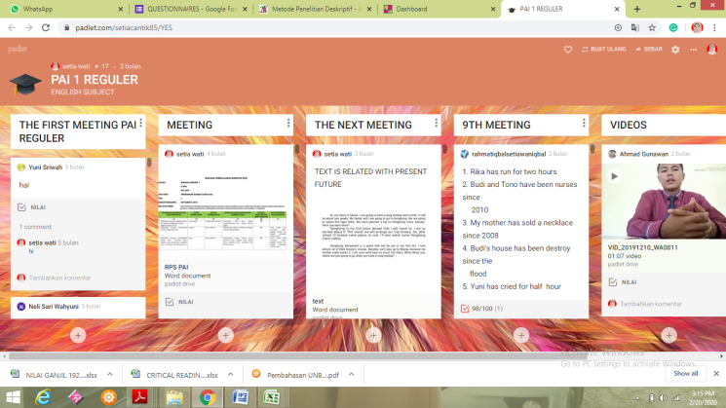
Picture 1. Padlet class PAI.1

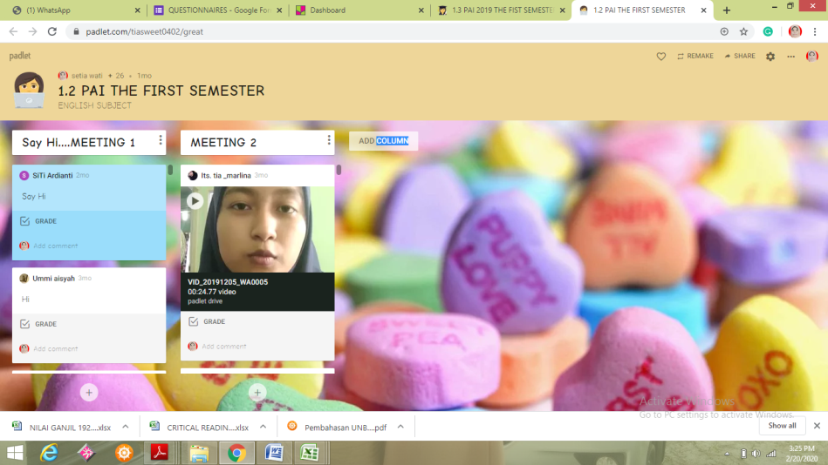
Picture 3. Padlet class PAI.2

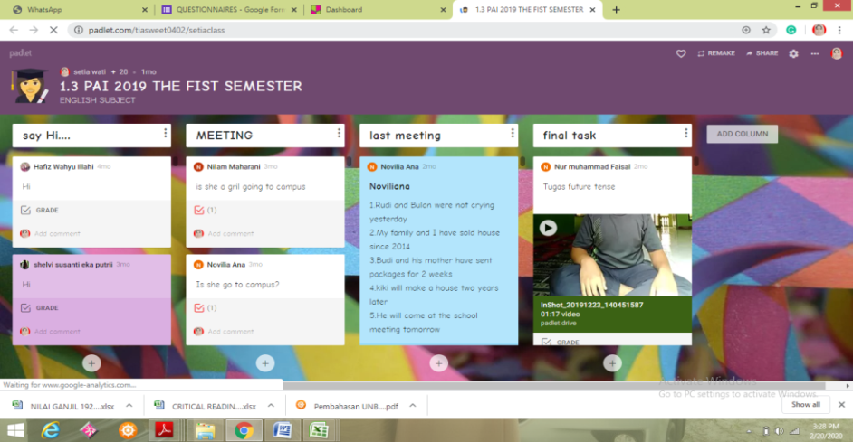
Picture 4. Padlet class PAI.3

- Method
This research used quantitative approach. The design of research was survey. Kumar (2006) said that survey has been further classified into four categories: (a) Descriptive (b) Analytical (c) School survey and (d) Genetic. Cohen, lawrence, and Keith (2007) was also supported that survey can be descriptive and analytic. This research, the writer conducted descriptive. Total population was the first semester of Islamic education STAI Hubbulwathan Duri. The undergraduate students have the same qualification and academic background before doing survey. They had ever learned English by using Padlet. Sample of this research was 61 respondents
The technique of research, the writer had collected data by doing questionnaires. it is supported by Kumar (2006) said descriptive research uses the questionnaire as research tool for data collection. The respondents were required to respond on each item based on the given rating scale: Strongly Agree (4), Agree (3), Disagree (2), and Strongly Disagree (1). The rating scale was presented in even number considering the issues of the existence of middle category (i.e. „Neither Agree Nor Disagree”, „Indifferent” or “Neutral”) that will prevent the participants for making the real choice (Dornyei, 2003). The writer shared the questionnaires by using google form. Every respondents answers the questionnaires by using google form in their handphone. Google form showed the result percentages of every questionnaires.

- Result
The result of the research showed that Total rating percentage of students’ perception using Padlet in learning English 54.5%. it was agree category. This categories showed the respondents Agree to use Padlet application in teaching learning process. Based on the questionnaires were also analyzed quantitatively to determine the mean and the standards deviation. The writer used SPPS 17 to analyze it. The respondents were asked to rate their agreement to the thirteen statements. It is showed mean score Agree (3). Overall mean is 3.15 and standart deviation is 0.673. The respondents gave positive responds..

- Discussion
- Descriptive analysis
The questionnaire items have been analyzed and the data was calculated in percentages. The result can be referred in Table below:
Table 1. Questionnaires analysis (Students’perception of using Padlet in learning English)
no | Items | Strongly agree | Agree | Disagree | Strongly disagree
1 | Learning the English language via Padlet is a good idea (belajar bahasa Inggris dengan padlet adalah ide yang bagus | 54.1% | 39.3% | 1.6% | 4.9%
2 | My interaction in Padlet messaging was clear.(interaksi saya pada pesan di padlet sangat jelas) | 27.9% | 63.9% | 4.9% | 3.3%
3 | My interaction in Padlet messaging was understandable. (interaksi saya dalam pesan padlet dapat dimengerti) | 32.8% | 59% | 6.6% | 1.6%
4 | It was easy for me to become skillful in discovering information via Padlet. (Mudah bagi saya untuk menjadi terampil dalam menemukan informasi melalui Padlet) | 29.5% | 54.4% | 9.8% | 3.3%
5 | Learning the English language using Padlet is convenient for me.(Mempelajari bahasa Inggris menggunakan Padlet mudah bagi saya) | 23% | 65.6% | 9.8% | 1.6%
6 | Padlet is convenient for academic engagement purposes. (Padlet nyaman untuk tujuan keterlibatan akademik.) | 29.5% | 54.1% | 14.8% | 1.6%
7 | Padlet allows me to academically engage with peers and lecturers at any time and any place. (Padlet memungkinkan saya untuk terlibat secara akademis dengan teman sebaya dan dosen kapan saja dan di mana saja) | 36.1% | 57.4% | 3.3% | 3.3%
8 | I found that Padlet is useful in my English language learning. (Saya menemukan bahwa Padlet berguna dalam pembelajaran bahasa Inggris saya) | 31.1% | 60.7% | 6.6% | 1.6%
9 | Using Padlet was effectively improved my English language learning. (Menggunakan Padlet secara efektif meningkatkan pembelajaran bahasa Inggris saya.) | 27.9% | 60.7% | 9.8% | 1.6%
10 | My performance in English language learning was improved by the use of Padlet.(Kinerja saya dalam pembelajaran bahasa Inggris ditingkatkan dengan penggunaan Padlet.) | 18% | 67.2% | 13.1% | 1.6%
11 | My performance in English writing has improved through the use of Padlet.(Kinerja saya dalam menulisbahasa Inggris telah meningkat melalui penggunaan Padlet.) | 26.2% | 55.7% | 13.1% | 4.9%
12 | Interaction via Padlet helped me to become active in English language activity. (Interaksi melalui Padletmembantu saya menjadi aktif dalam kegiatan bahasa Inggris.) | 36.1% | 54.1% | 6.6% | 3.3%
13 | In the future, I will use Padlet in learning the English language. (Di masa depan, saya akan menggunakanPadlet dalam mempelajari bahasa Inggris.) | 18% | 65.6% | 14.8% | 1.6%

Based on the table above, 54% respondents respond strong agree about Learning the English language via Padlet is a good idea. My interaction in Padlet messaging was clear, it had been responded 63.9% agree. My interaction in Padlet messaging was understandable 59% agree. It was easy for me to become skillful in discovering information via Padlet 54.4% agree. Learning the English language using Padlet is convenient for me 65.6% agree. Padlet is convenient for academic engagement purposes 54.1% agree. Padlet allows me to academically engage with peers and lecturers at any time and any place 54.7% agree. I found that Padlet is useful in my English language learning 60.7% agree. Using Padlet was effectively improved my English language learning 60.7% agree. My performance in English language learning was improved by the use of Padlet 67.2% agree. My performance in English writing has improved through the use of Padlet 55,7% agree. Interaction via Padlet helped me to become active in English language activity 54.1% agree. In the future, I will use Padlet in learning the English language 65.6% agree. Total rating percentage of respondents’ respond was 54.5%. Categories of the percentages conducted below:

Minimal percentage 25%
Maximal percentage 100%
By 4 scales
Range percentages | Scales
0 - 25% | Strongly disagree
26% - 50% | Disagree
51% - 75% | Agree
76% - 100% | Strongly agree

Total rating percentage of students’ perception using Padlet in learning English 54.5%. it was agree category. This categories showed the respondents Agree to use Padlet application in teaching learning process. The respondents gave positive responds. It meant that Padlet platform gave positive perception to use it in English learning process
Data collected from the questionnaires were also analyzed quantitatively to determine the mean and the standards deviation. The writer used SPPS 17 to analyze it. The respondents were asked to rate their agreement to the thirteen statements.
Table 2. Questionnaire results: descriptive statistics
no | Items | Mean | Std. Dev
1 | Learning the English language via Padlet is a good idea (belajar bahasa Inggris dengan padlet adalah ide yang bagus | 3.43 | 0.763
2 | My interaction in Padlet messaging was clear.(interaksi saya pada pesan di padlet sangat jelas) | 3.16 | 0.663
3 | My interaction in Padlet messaging was understandable. (interaksi saya dalam pesan padlet dapat dimengerti) | 3.23 | 0.643
4 | It was easy for me to become skillful in discovering information via Padlet. (Mudah bagi saya untuk menjadi terampil dalam menemukan informasi melalui Padlet) | 3.13 | 0.718
5 | Learning the English language using Padlet is convenient for me.(Mempelajari bahasa Inggris menggunakan Padlet mudah bagi saya) | 3.1 | 0.625
6 | Padlet is convenient for academic engagement purposes. (Padlet nyaman untuk tujuan keterlibatan akademik.) | 3.11 | 0.709
7 | Padlet allows me to academically engage with peers and lecturers at any time and any place. (Padlet memungkinkan saya untuk terlibat secara akademis dengan teman sebaya dan dosen kapan saja dan di mana saja) | 3.26 | 0.628
8 | I found that Padlet is useful in my English language learning. (Saya menemukan bahwa Padlet berguna dalam pembelajaran bahasa Inggris saya) | 3.21 | 0.635
9 | Using Padlet was effectively improved my English language learning. (Menggunakan Padlet secara efektif meningkatkan pembelajaran bahasa Inggris saya.) | 3.15 | 0.654
10 | My performance in English language learning was improved by the use of Padlet.(Kinerja saya dalam pembelajaran bahasa Inggris ditingkatkan dengan penggunaan Padlet.) | 3.02 | 0.619
11 | My performance in English writing has improved through the use of Padlet.(Kinerja saya dalam menulisbahasa Inggris telah meningkat melalui penggunaan Padlet.) | 3.03 | 0.774
12 | Interaction via Padlet helped me to become active in English language activity. (Interaksi melalui Padletmembantu saya menjadi aktif dalam kegiatan bahasa Inggris.) | 3.21 | 0.71
13 | In the future, I will use Padlet in learning the English language. (Di masa depan, saya akan menggunakanPadlet dalam mempelajari bahasa Inggris.) | 2.98 | 0.619
 | overall | 3.15 | 0.673
*N=61
From table above showed that overall mean is 3.15 and standart deviation is 0.673. It meant learning the English language via Padlet is a good idea, interaction in Padlet messaging was clear, interaction in Padlet messaging was understandable, It was easy for me to become skillful in discovering information via Padlet, learning the English language using Padlet is convenient, Padlet is convenient for academic engagement purposes, Padlet allowsundergraduate students to academically engage with peers and lecturers at any time and any place, Padlet is useful in my English language learning, Using Padlet was effectively improved my English language learning, their performance in English language learning was improved by the use of Padlet, their performance in English writing has improved through the use of Padlet, interaction via Padlet helped me to become active in English language activity, In the future, they will use Padlet in learning the English language. The respondents gave positive respond for all questionnaires that had given.

- The finding
Based on the data collected from the questionnaires were also analyzed quantitatively to determine the mean and the standards deviation. The writer used SPPS 17 to analyze it. The respondents were asked to rate their agreement to the thirteen statements. It is showed mean score Agree (3). Overall mean is 3.15 and standart deviation is 0.673. It has positive perception using Padlet in English teaching Learning Process both in classroom and in outside.
- Conclusion
From data obtained through the questionnaires distributed to 61 respondents of the first semester Islamic Education Department STAI Hubbulwathan Duri, the researcher could conclude that respondents responds positive perception the use of this media in teaching learning process. Most of respondents throught that Padlet was something new to them. Padlet is easy to access and use because it is a free application and only needs internet connection. It can be accessed by using any devices such as phone, tablet, and computer. Padlet can turn the old traditional way of learning become the interesting one. It is because Padlet has interesting features to make the teaching and learning activity becomes more active. Interaction via Padlet also helped them to become active in English language activity.

References
Altun, M. (2015). The Integration of Technology into Foreign Language Teaching. International Journal on New Trends in Education & their Implications (IJONTE), 6(1).
Bower. M. 2015. A typology of Web 2.0 learning technologies. EDUCAUSE Digital Library, Retrieved June 2015, from http://www.educause.edu/library/resources/typology-web-20-learning-technologies.
Boyd, D. 2007.The significance of social software. In T. N. B. J. Schmidt (Ed.), Blogtalks, Reloaded: Social Software Research & Cases. pp. 15-30. Norderstedlt: Books on Demand.

Byrne, R. (2015). Collaborative Research Tools. School Library Journal, 61(3), 16.
Cohen, lawrence, and Keith. 2007. Research Methods in Education. London and New York: Routledge.
Dörnyei, Z. 2003.Questionnaires in Second Language Research: Constructing, Administrating and processing. Lawrence Erlbaum Associates Publisher, London.
Fageeh.A.I. (2011) EFL Learners’ Use of Blogging for Developing Writing Skills and Enhancing Attitude towards English Learning: an Exploratory Study. Journal of Language and Literature, 2 (1),31-38
Fuchs, B. (2014). The Writing is on the Wall: Using Padlet for Whole-Class Engagement. LOEX Quarterly, 40(4), 7-9.
Gregoire, R., Bracewell, R., & Laferriere, T. (1996). The contribution of new technologies to learning and teaching in elementary and secondary school. Unpublished .
Kumar, Yosegh Singh. 2006. Fundamental of Research Methodology and Statistic. New Delhi : New Age International.
Kaya, H. (2015). Blending Technology with Constructivism: Implications for an ELT Classroom. Teaching English with Technology, (1), 3-13.
Shield, J. 2014.Virtual Toolkit.Screen Education 75:92-93.
Social media for teaching and learning series. www.uq.edu.au/tediteach/social-media-tools
Thomas, J.D.E.Morin, D.&Ly.S.(2014). Delivery Method and Persistence and Performance. In Proceedings of Worlds Conference on Educational Multimedia, Hypermedia and Telecommunications, Tampere, Finland, 1797-1801.
Wood, M. 2016. Padlet a graffiti wall for today‟s agricultural teacher.Agricultural Education

