Development Of Digital Media Based On Local Wisdom To Increase Interest In Learning Social Studies In Kuantan Singingi District
Yuliantoro ¹ , Dewi Liesnoor Setyowati ² , Thriwaty Arsal ³ , Apik Budi Santoso ⁴

- Semarang State University; email: yuliantoro21@students.unnes.ac.id
- Semarang State University; email: liesnoor2015@mail.unnes.ac.id
- Semarang State University; email: thriwaty_arsal@mail.unnes.ac.id
- Semarang State University; email: apikbudi@mail.unnes.ac.id
ARTICLE INFO |  | ABSTRACT
Keywords:  Development;  Digital Media;  Local Wisdom;  Learning Interest |  | The junior high school social studies curriculum requires teachers to integrate material with problems that students can solve from their surroundings. This research is motivated by the lack of innovation in using media in learning and teachers' inadequate application of local wisdom closest to students. Teachers often exemplify local wisdom that is far from students' lives, thus affecting students' interest in social studies learning. Therefore, this study aims to increase interest in learning social studies with a digital media approach based on local wisdom. The research design uses the ADDIE development model approach, consisting of analysis, planning, development, implementation, and evaluation. This development process was carried out in a structured and systematic manner based on the model procedures used. The product was validated by experts and tested in small groups (40 students in 1 school) and large groups (92 students in 2 schools). The results showed that the material and media were very feasible with expert validation scores of 94% and 95%, and student response scores of 90% and 92%. In addition, student interest in learning social studies increased significantly, from 60% to 90% in small group trials and 62% to 93% in large group trials after using digital media in social studies learning at school. It can be explained that the application of digital media resulting from the development has a positive impact on student learning interest with the criteria of "very high". This shows that this development can be recommended for implementation in schools because it has an impact on increasing student learning interest.
Article history:
Received 2025-08-05
Revised 2025-08-30
Accepted 2025-09-00
 |  | This is an open access article under the CC BY-NC-SA license.
Corresponding Author :
Yuliantoro
Universitas Negeri Semarang, Semarang, Indonesia; yuliantoro21@students.unnes.ac.id

- INTRODUCTION
Education is a conscious, planned effort to create a learning and teaching atmosphere so that students actively develop their potential to have spiritual religious strength, self-control, personality, intelligence, noble morals, and skills needed by themselves and society (Pristiwanti, et al., 2022). Indonesian national education mandates that developing abilities and forming a dignified national character and civilization in order to educate the nation's life aims to develop all the potential of students (Law of the Republic of Indonesia No. 20 of 2003). Education is structured in the national goals clearly that a conscious effort to educate the nation's life is the main goal. This is followed at all levels of education including Junior High School. The Junior High School level in the social studies education curriculum is part of the national curriculum designed to equip students with knowledge, skills, attitudes, and social values. The social studies subject in Junior High School integrates elements from various social science disciplines such as history, geography, economics, and sociology (Depdiknas 2006); Kemdikbud (2022). Social studies education combines several social science disciplines to understand a social phenomenon holistically (Sapriya, 2009). Understanding social studies education with an interdisciplinary approach requires students to understand learning problems in an integrated manner, both in terms of mastery of knowledge of history, geography, economics, and sociology. By understanding the context of these disciplines, students will have contextual knowledge in mastering the material. Therefore, students are required to have the ability to think critically and analytically about social issues related to social studies. Interesting in the challenges of learning social studies is very complex for students. In addition to the main challenges are facilities and infrastructure such as book sources and classroom facilities. Solikhah, (2018); Kartika, (2019); Arista, (2023); Natasyah, (2024) Social studies learning also faces other challenges regarding teacher skills, such as the use of technology. A lack of innovative teaching skills is also a problem. Nahla (2022) conducted a literature study that showed that students' low interest in social studies is caused by irrelevant material, monotonous teaching methods, the perception that social studies is difficult, and a lack of support from the family and school environment. Therefore, it is recommended to implement a contextual curriculum and innovative teaching methods to make it more relevant to students' lives.
The main problem in the process and implementation of social studies learning is the lack of student interest in this learning. The reason students expressed the lack of interest in social studies learning is the teacher's ability to teach using social studies thematic themes and the lack of real-life examples around students' lives. According to Mauhazizin, (2012); Badrus, S., et al., (2014); Fatmala (2022), teacher pedagogical competence influences student interest. It was found that teachers with effective pedagogy can increase interest in learning, but are limited by environmental factors and limited teacher competence. Seeing this problem, social studies learning should be carried out by teachers optimally, the teacher's skills are truly maximized so that students understand social studies learning knowledge well, thereby increasing their interest in learning. Efforts to increase interest in social studies learning require various formulations in learning, for example using interactive models in learning, using varied media, or using strategic and innovative approaches in learning. Strategic approaches in social studies learning are problem-based or project-based. This learning requires more student activity in learning. Therefore, teachers act as facilitators in learning by first guiding the various learning requirements. A learning approach with appropriate strategies can have a positive impact on students' learning interests.
According to Sardiman, A., (2012); Sugiono, (2013); Suyitno, (2014) development is the process of creating and testing the effectiveness of a product through needs analysis, design, and testing so that it can be used widely in the community. This process is carried out in stages and aims to produce a better product and according to user needs. It is understood that development is the process of designing to testing to the evaluation process until validity is obtained to be determined for continuous use. Prastowo, A., (2015); Sadiman, A., et al., (2018); Ningtiyas, (2025); Teaching materials are learning media that play an important role in delivering material more easily and systematically. With teaching materials, the material has been structured so that it helps teachers in teaching and facilitates the achievement of predetermined basic competencies. Therefore, teaching materials are actually media that help teachers in delivering learning materials based on planned learning outcomes. Sari et al., (2021); Andriani et al., (2023); Rahmawati et al., (2023); Hayati, (2025) Digital media is a structured media containing material in the form of text, images, or sound, and presented in digital format. This media integrates multimedia elements, thus allowing users to interact more actively with the content. Therefore, media design is the process of developing interactive materials based on digital technology to facilitate teachers in delivering material and impact student engagement in learning.
According to Koentjaraningrat, (2009); Setiawan et al., (2021); local wisdom is a form of knowledge and cultural values held by certain communities. This knowledge includes the harmonious relationship between humans and nature, alternative economic systems, as well as social and moral norms that form the basis of ethics in everyday life. Local wisdom that is used as digital media is forbidden forests and forbidden rivers. Forbidden forests are traditional values in protecting the natural environment through community customary prohibitions, there are sanctions for violators of these rules if they do not heed them. Forbidden rivers are a prohibition on taking resources in the river flow within a certain time as part of the results of deliberations by indigenous communities, customary leaders also have rules of sanctions in them. Digital media based on local wisdom through forbidden forests and forbidden rivers , is a process of developing social studies learning materials designed through a process of enriching local wisdom values of the community which are synchronized through social studies learning materials and themes. This synchronization is part of an effort to increase the understanding of social studies learning contextually what students see and do in their surroundings. The material and themes in social studies lessons are heavily related to culture and interaction, evident in all classes at the junior high school level. Teachers can exemplify these themes by using real-life examples from the students' surroundings. Examples of cultural themes can be exemplified by the local wisdom traditions of the students' communities, fostering their interest because they know, see, and even experience events. Meaningful learning stems from strong student engagement. If teachers can implement such practices, then social studies lessons will undoubtedly be of interest to all students. These are all approaches to improving student knowledge and interest in learning.
The material and themes of junior high school social studies learning are linked to environmental conservation through local wisdom values. This social studies learning, linked to the theme of local wisdom, aims to increase students' interest in learning. Even local wisdom-based learning research continues to be applied in social studies learning and is being tested in various schools aimed at maturity in implementation, and will subsequently provide improvements in social studies learning and change positive responses from students to social studies learning. The results of research by Sriyanti, (2019); Purnami, (2020); Nikmah, S., (2020); Dewi (2023); Azmi R., (2025) wisdom-based learning increases students' interest in learning and academic results in social studies. This is an example of the hard work of teachers to try to improve deficiencies in social studies learning. The teacher's focus is to attract students' interest in social studies learning, so teachers try to link learning themes to the lives faced and experienced by students. BSKAP Kemendikbudristek, (2022); Suparno, (2022) Junior High School Social Studies material related to culture and local wisdom for grades VII phase df to IX: VII phase d (Concept of space and interaction (maps, atlases, sketches, natural phenomena, impacts of social interaction)), VIII phase e (Continuation of social interaction, socio-cultural change, social institutions, community dynamics), and IX phase f (Challenges of Indonesian development & international cooperation (SDGs, global-social conditions)). With the material and focus of the Social Studies learning theme, the teacher tries to link the problems in the Social Studies learning material with the local wisdom approach that exists around the students (showing real examples of local wisdom values). By teachers bringing examples around the students, learning is easy to understand and then increases their interest in learning.
Based on initial simple research on the implementation of social studies learning in 2 junior high schools in Kuantan Singingi Regency, all teachers in teaching both in grades VII, VIII and IX in material phases d, e, and f tend to use conventional approaches, the media used is only monotonous such as ppt and in exemplifying material related to culture and social interaction (exemplifying local wisdom values are many that are far from the lives of students) so that it has an impact on the lack of interest in social studies learning. For this reason, the author is interested in researching the development of digital media based on local wisdom in an effort to increase students' interest in learning social studies. With this application, hopefully the results of this study will be a recommendation for teachers to be creative in social studies learning in exemplifying real material in students' lives and innovating in using appropriate media and learning strategies according to the material and learning outcomes.

- METHODS

2.1 Research Approach
This study uses Research and Development (R&D) with the ADDIE development model , consisting of five stages: analysis, design, development, implementation, and evaluation . This model was chosen because it has a systematic and procedural approach that allows researchers to design, develop, and evaluate teaching materials in a structured manner. Mulyatiningsih, (2011); Sugiyono (2015); Slamet (2022) define the ADDIE model as a systematic framework consisting of five main phases: analysis, design, development, implementation, and evaluation. This model is considered highly rational and comprehensive, suitable for developing various educational products such as learning media, teaching materials, methods, and other learning tools.
2.2 Research Subjects
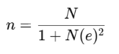
Based on Sevilla, (1992); Sugiyono, (2015) Slovin's formula to determine the sample size from a population of 120 students using the formula: margin of error 10-15% then the research sample was tested on small groups (40 students in 1 school) and large groups (92 students in 2 schools). The research was conducted in 2 junior high schools located in Sentajo Raya and Singingi Districts, Kuantan Singingi Regency, Riau Province. The research was carried out from January to April 2025.
2.3 Research Design and Procedures
The research steps are as follows: Analysis stage; direct observation of the school, interviews with social studies teachers and students to identify social studies learning problems, teachers when teaching in class, media and learning strategies implemented by social studies teachers. Interviews with students regarding the level of interest in learning social studies. The stages of the ADDIE development model are carried out sequentially and in line with project procedures to support the success of digital media development. Presented in the following scheme:
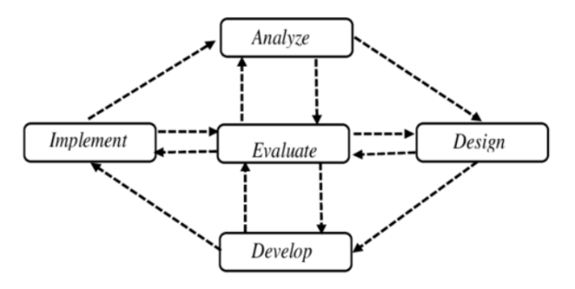
Figure 1. ADDIE Model Stage Scheme
Design stage ; The digital-based media design process uses a pre-selected platform. It begins with collecting materials from various sources such as books, journals, and documents on local wisdom of the forbidden forest and forbidden river, then linked to relevant curriculum materials on culture and social interaction. Then the researcher creates a storyboard of the content structure: title, user manual, table of contents, materials, glossary, and bibliography. At this stage, a questionnaire instrument is also created which will later be validated by material and media experts, and a questionnaire response to student learning interests.
The development stage of digital media products was developed through Canva and Heyzine flipbooks, converted into interactive media. Material validation, carried out by competent experts in the field of Social Studies aims to assess the feasibility of the material. Media validation by media experts who have competence in the field of media innovation to assess the appearance, presentation, and understandability of the design. Improvements were made based on input from material experts and the final product media can meet the feasibility standards. Implementation stage, Media was tested in two stages: a small group trial in 1 class VII of Junior High School A and a large group in 2 classes in Junior High School A & B. This test aims to see how effective digital media is in increasing students' interest in learning Social Studies. The evaluation stage is the final part of the development. Evaluation is carried out through measurement and analysis of data obtained during implementation, both in the form of student responses and expert assessments. Evaluation in this study includes qualitative and quantitative data analysis. Qualitative data was obtained from documentation, interviews, and observations that describe student responses and input from experts on learning media.
Validation questionnaires from material experts and media experts, student response questionnaires on teaching media, and social studies learning interest questionnaires. Each questionnaire was compiled based on predetermined indicators: content suitability, language clarity, and visual appearance. These instruments were compiled systematically to ensure the validity of the data obtained. Riduwan, & Akdon, (2010); Sudijono, (2014); Arikunto (2016); Quantitative analysis was conducted using percentage analysis techniques. Namely, by comparing the scores obtained with the maximum score, then converted into feasibility categories based on a classification table. The results show the level of success of the media developed in social studies learning, meeting the feasibility criteria for increasing students' interest in learning social studies, culture, tradition, and interaction. The following digital media feasibility qualifications:
Table 1. Qualification eligibility Media Digital
Eligibility Results | Qualification | Criteria
85%-100% | Very good | Very Worthy
70%-84% | Good | Worthy
55%-69% | Pretty good | Quite Decent
40%-54% | Not good | Less than worthy
0%-39% | Very less | Not feasible

Miles and Huberman (1994) analyzed qualitative data, presenting interactive analysis steps, namely through three main stages: data reduction, data presentation, and conclusion drawing/verification. The data reduction stage was carried out by sorting, focusing, and simplifying the initial data obtained from observations, interviews with teachers during the observation stage, and written responses from material and media experts. Repetitive or irrelevant data were grouped thematically for further in-depth study. Next, in the data presentation stage, the researchers organized the results of the observations and responses into descriptive narratives, thematic matrices, and relevant direct quotations, making it easier to see patterns and relationships between the data. The formula for the percentage of feasibility can be explained as follows:
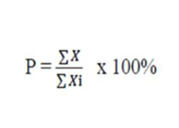
Explanation:
P: Eligibility Percentage
X: Total Validator Answer Score (actual score)
Xi: Maximum Score 100%: Constant Number

The final stage is drawing conclusions and verifying, where researchers review the summarized findings to ensure the consistency and validity of the data's meaning. The results of this analysis are used to strengthen interpretations of the feasibility, effectiveness, and acceptability of digital media products by end-users, teachers, and students. These results ensure that all input from informants is used as a basis for decision-making in developing and refining interactive media products that meet student needs .

- FINDINGS AND DISCUSSION

3.1 Results of Digital Media Development
The development of digital media based on local wisdom (Forbidden Forest and Forbidden River) successfully passed all stages in the ADDIE model, starting from the analysis stage to the evaluation stage. In the analysis stage, researchers identified problems that emerged in Junior High School A and Junior High School B in Sentajo Raya and Singingi Districts, Kuantan Singingi Regency, namely the limited innovation of social studies learning media and the limitations of teachers in explaining examples of local wisdom values closest to students so that social studies learning was less interesting. For this reason, digital media was developed that combined narratives, images, and videos as a form of adaptation to school conditions. Furthermore, in the design stage, researchers compiled materials based on Basic Competencies for grades VII, VIII, & IX with phases d, e, f of cultural and social interaction materials. The materials were systematically arranged through a storyboard containing components such as covers, concept maps, material content, and bibliography. Research instruments were also designed including validation questionnaires from media experts, material experts, student response questionnaires, and learning interest questionnaires. The development stage is carried out by compiling and editing the material through Canva and converting it into digital media using the Heyzine platform , as seen in the following image:
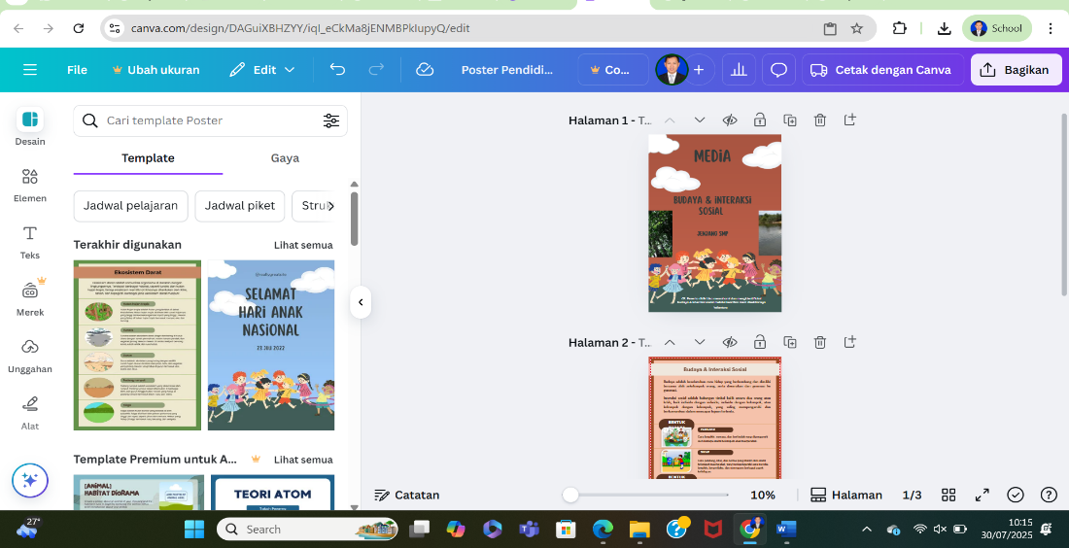
Figure 2. The Process of Compiling Digital Media Materials Using Canva
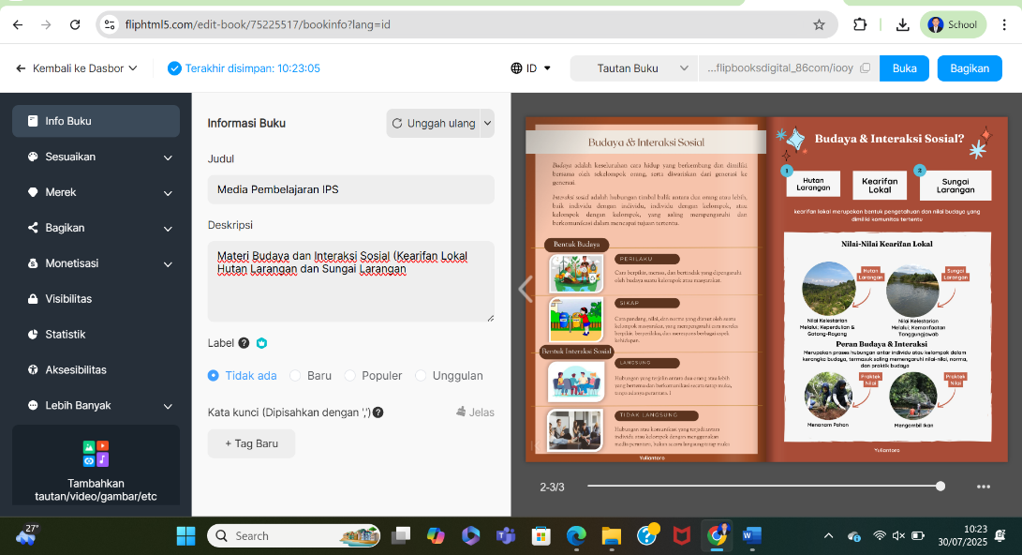
Figure 3. Digital Media Conversion Process Through the Heyzine Platform
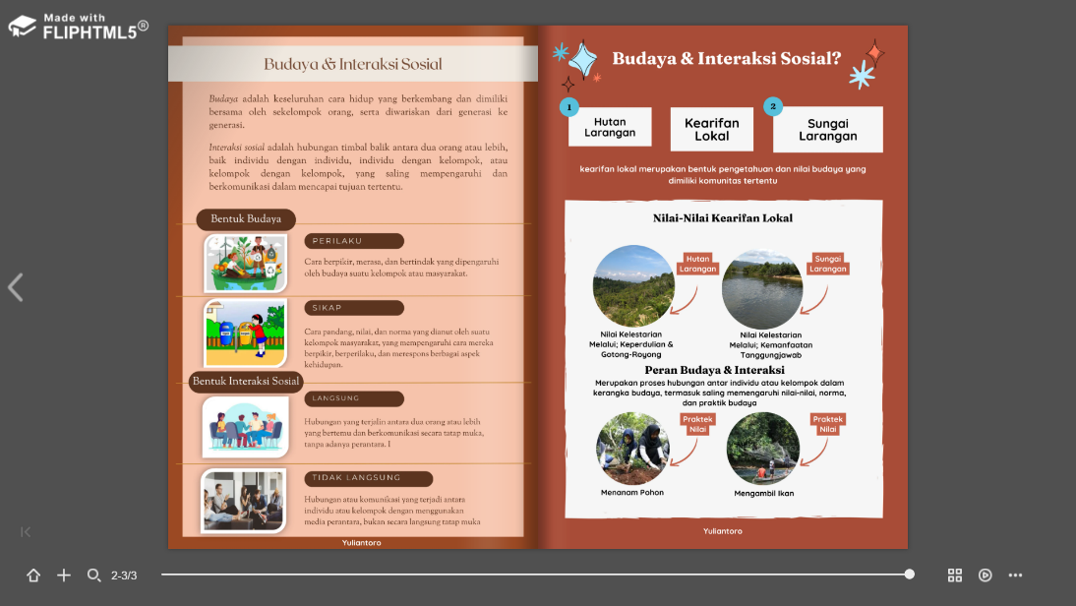
Figure 4. Full Digital Media View
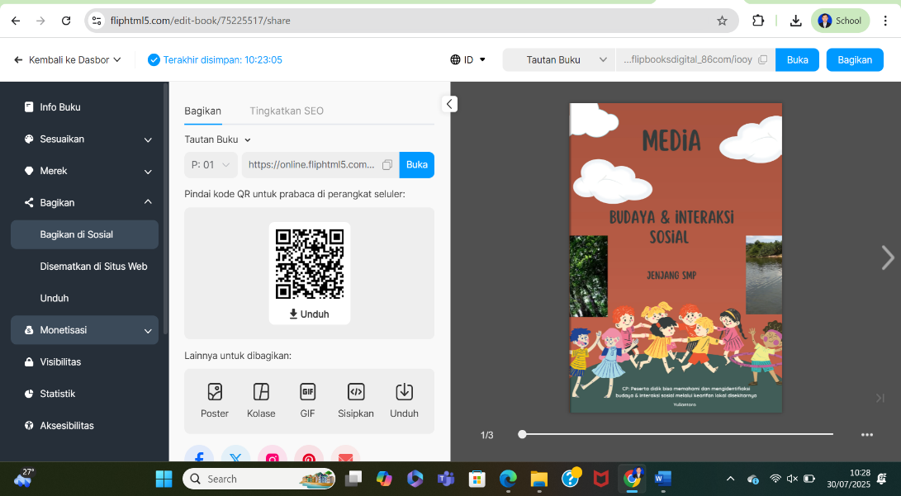
Figure 5. Digital Media Can Be Accessed Through Links or QR Codes

The results of developing digital media based on the local wisdom of the forbidden forest and forbidden river are obtained if teachers allow digital media to be accessed in addition to using infocus monitors in the classroom. This media can also be accessed via gadgets or personal computers during social studies learning, supported by a highly adequate technology-based laboratory, greatly facilitating teachers in delivering material through digital media. This successfully developed media can be accessed through links and QR codes, demonstrating that it is based on contemporary technology.
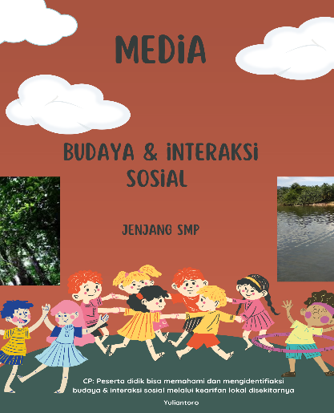

Figure 6. Digital Media Coverage Display

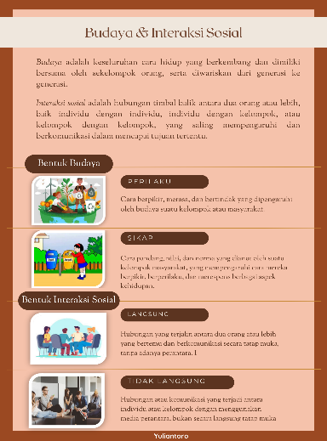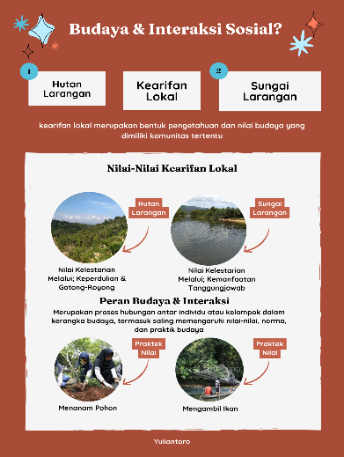

Figure 7. Digital Media Content Display
The implementation stage involves the application of digital media in social studies learning to students. Expert input and student feedback on improvements to the media are still ongoing. After the material is compiled using the Canva platform, it is then converted into digital media through the Heyzine platform. The evaluation stage then involves submitting the digital media for expert review, both from material experts and media experts. After improvements based on expert input, the digital media can be implemented as standard in the classroom and even become a reference in social studies learning in junior high schools, implemented by other social studies teachers.
3.2 Expert Assessment Results
The context of digital media shows that the material presentation structure has accommodated the scaffolding principle, where information is presented gradually starting from the general concept of local wisdom of the forbidden forest and the forbidden river. The images presented in digital media are not merely decorative, but are relevant and factual visual documents, such as photos of forms of local wisdom related to cultural material and social interactions. This can be concluded that digital media with contextual visual elements will be more capable of increasing the cognitive engagement of participants compared to conventional media such as ppt. The results of the analysis of the feasibility assessment of digital media are shown below:
Table 2. Results of the Digital Media Feasibility Assessment
No | Stage Evaluation | Total Score | Percentage | Eligibility
1 | Evaluation Expert Material | 47 | 94% | Very Worthy
2  3  4 | Evaluation Expert Media  Small Group (Students)  Large Group (Students)  Average | 52  1440  3386 | 95%  90%  92% | Very Worthy  Very Worthy  Very Worthy  Very Worthy
The product results were validated by two experts, namely material experts and media experts. The results of the material expert validation showed that a score of 47 was obtained from the total maximum score, with a percentage of 94% which was classified as "Very Good" category of "Very Eligible" eligibility criteria for testing. Validation by media experts also provided higher results, namely a score of 52 from the total maximum score, with a percentage of 95%, which was in the "Very Good" category of "Very Eligible" eligibility criteria. The validated product was then implemented in small group trials (30 students) and large groups (92 students) in grades VII, VIII, and IX at Junior High School A & B. In the small group trial, students showed enthusiasm in understanding the contents of digital media, with the results of the participant response questionnaire assessment reaching a total score of 1440 from the maximum score, or 91% in the "Very Good" category. The large group trial, with a total score of 3386 from the maximum score, or 94%, was categorized as "Very Good".
3.3 Results of Students' Learning Interest
Based on the results of the application of digital media to increase student learning interest in junior high school social studies, this learning interest was assessed in two groups (small and large groups). The results of the learning interest assessment are presented in the following table:

Table 3. Learning Interest Results
No | Implementation Stage | Media Usage |  | Information
No | Implementation Stage | Before | After | Information
1  2 | Small Group  Large Group | 60%  62% | 90%  93% | Very high  Very high

The results of students' learning interest before and after the use of digital media based on local wisdom of the forbidden forest and forbidden river in social studies learning. The implementation was carried out in small groups, students' learning interest increased from a score of 1200 (60%) to 1800 (90%), rising from the category of "Medium" to "Very High". While the implementation in large groups, the learning interest score increased from 2852 (62%) to 4278 (93%), also moving from the category of "Medium" to "Very High". This increase indicates that the digital media based on local wisdom that was implemented was able to provide a more interesting learning experience and arouse students' curiosity about social studies learning materials in junior high schools, thus having an impact on increasing learning interest.

- CONCLUSION
The purpose of this study is to reveal that the application of digital media based on local wisdom can increase students' interest in learning social studies in junior high schools. However, before implementing the media, it begins with a media development process and validates the feasibility of using the media by material experts and media experts. The results of the development through the ADDEI approach, starting from the analysis stage, identify problems that arise at the junior high school level in Kuantan Singingi Regency, namely the limitations of social studies learning media innovation and teachers' limitations in explaining examples of local wisdom values closest to the participants. For this reason, digital media was developed that combines narratives, images, and videos as a form of adaptation to school conditions. Furthermore, in the design stage, researchers compiled materials based on Basic Competencies for grades VII, VIII, & IX with phases d, e, f of cultural material and social interaction. The materials were systematically arranged through a storyboard containing components such as covers, concept maps, material content, and bibliography. The research instruments were also designed including validation questionnaires from media experts, material experts, student response questionnaires, and learning interest questionnaires. The development stage is carried out by compiling and editing material through Canva and converting it into digital media using the Heyzine platform.
The implementation stage involves the application of digital media in social studies learning to students, and in this implementation, there is still a process of expert input and student responses to the improvement of this media. The evaluation stage then digital media can be submitted for expert testing, both material experts and media experts. After improvements based on expert input, digital media can be implemented standardly in the classroom and even become a reference in social studies learning in junior high schools applied by social studies teachers in other schools. After the implementation, the increase in student learning interest was measured, showing small and large group trials showing very high criteria after using digital media based on local wisdom.
Thanks to Allah SWT and family (parents, wife, children and younger siblings, as well as the institutions of Riau University and Semarang State University), for their moral and material support in completing this article.

REFERENCES
Andriani, R., Hunaifi, AA, & Damariswara, R. (2023). Development of digital flipbook media based on Kediri local wisdom on the material of observing characters in fictional stories for grade IV Elementary School . SOCIAL: Journal of Social Studies Education Innovation, 3(4), 162-174. https://doi.org/10.51878/social.v3i4.3070.
Arikunto, S. (2016). Basics of Educational Evaluation (2nd or 3rd Revised Edition). Jakarta: Bumi Aksara.
Arista Pratiwi, D. (2023). Teachers' obstacles in developing social studies lesson plans at Muntilan & Salam Middle School . Journal of Social Studies, Vol. 8, No 1
Azizah, PI, Dhewantoro, HNS, & Basyari, A. (2022). Integration of Local Wisdom in Junior High School Social Studies Learning in Indonesia. Langgong: Journal of Social Sciences and Humanities, 2(1), 37–48. https://doi.org/10.30872/langgong.v2i1.2264
Azmi, R., & Zainil, M. (2025). The Impact of Local Wisdom-Based Social Studies Learning on Students' Social Identity. Journal of Educational Technology and Learning, 2(4), 940-947. https://jurnal.kopusindo.com/index.php/jtpp/article/view/815
Education Curriculum and Assessment Standards Agency ( BSKAP ). Social Studies Learning Outcomes Book for Junior High Schools/Islamic Junior High Schools Independent Curriculum, Phases D–F . Jakarta: Ministry of Education, Culture, Research, and Technology.
Ministry of National Education. (2006). Guidelines for Developing Curriculum at the Educational Unit Level for Elementary and Secondary Education. Jakarta: Ministry of National Education.
Dewi, MLPMK, Lasmawan, IW, & Sriartha, IP (2021). Development of Subak Local Wisdom-Based Learning Video Media in Social Studies Lessons at SMP Negeri 1 Singaraja . Journal of Technology and Vocational Education, 20(2). https://doi.org/10.23887/jptkundiksha.v20i2.65917.
Fatmala, A. (2022). Analysis of Social Studies Teachers' Pedagogical Competence on Students' Learning Interests at SMP Negeri 10 Surabaya. Journal of Social Studies Education Dialectics, 2(2), 117–130. https://doi.org/10.26740/penips.v2i2.48365
Hayati RH, et al. (2025). Enhancing Critical Thinking Skills Through the TACK Model with Digital Flipbook Integration. Al-Ishlah: Jurnal Pendidikan Vol.17, 1 pp. 1440-1461. DOI: 10.35445/alishlah.v17i1.6191.
Kartika, F. (2019) . Challenges of social studies education in the era of globalization . Dewantara Journal Vol. 3 No 2.
Ministry of Education and Culture. (2022). Guide to Implementing the Independent Curriculum. Jakarta: Ministry of Education, Culture, Research, and Technology.
Koentjaraningrat. (2009). Introduction to Anthropology. Jakarta: Rineka Cipta.
Mauhazizin, AS (2012). The Influence of Teacher Competence and Learning Motivation on Learning Outcomes in Social Studies Subjects in Junior High Schools in Purwakarta Regency. Thesis. Bandung; Indonesian University of Education.
Miles, M. B., & Huberman, A. M. (1994). Qualitative Data Analysis: An Expanded Sourcebook (2nd ed.). Thousand Oaks, CA: Sage Publications.
Mulyatiningsih, E. (2011). Applied Research in Education and Engineering. Yogyakarta: UNY Press.
Nahla, Z., Setiawan, B., & Ulandari, T. (2022). Lack of Student Interest in Social Studies Subjects at the Junior High School Level . JIPSINDO.
Natasya, Desy Safitri & Sujarwo. (2024). Barriers to the implementation of the Independent Curriculum in social studies learning at SMP 11 Muhammadiyah. Sindoro Journal: Cendikia Pendidikan, Vol. 3 No. 10. https://doi.org/10.9644/sindoro.v3i10.2619
Nikmah , S., Purnomo, A., & Nisa, ANS (2020). Local Wisdom-Based Social Studies Learning (Case Study at SMP Negeri 1 Jepara). Sosiolium: Journal of Social Studies Learning. 2(1), https://doi.org/10.15294/sosiolium.v2i1.41324.
Ningtiyas, R. (2025). Development of Pop-Up Book Teaching Materials containing student creativity on fairy tale material for grade III students of SDN Sambirejo. Thesis. Kediri: Universitas Nusantara PGRI Kediri.
Prastowo, A. (2015). Creative Guide to Making Innovative Teaching Materials. Yogyakarta: Diva Press.
Pristiwanti, D., et al. (2022). Understanding Education . Journal of Education and Counseling (JPDK), 4(6), 7911–7915. https://doi.org/10.31004/jpdk.v4i6. 9498
Purnani, S., & Mulianingsih, F. (2020 ). Implementation of Local Wisdom-Based Social Studies Learning at SMP Negeri 2 Jatinom, Klaten Regency. Sosiolium: Journal of Social Studies Learning, 2(1), 35-39. https://doi.org/10.15294/sosiolium.v2i1.39847
Rahmawati, R., et al. (2023). Development of digital flipbook learning media using the Canva application in thematic learning for class V elementary schools. Perkhasa Basic Education Journal, 9(2), 337–350. https://doi.org/10.31932/jpdp.v9i2.2259.
Republic of Indonesia. (2003). Law of the Republic of Indonesia Number 20 of 2003 concerning the National Education System. Jakarta: State Secretariat.
Rete, P., et al. (2025). Development of Local Wisdom-Based Instructional Materials to Enhance Reading Skills of Fifth-Grade Elementary School Students. Al-Ishlah: Journal of Education Vol.17, 1, pp. 1300-1321. DOI: 10.35445/alishlah.v17i1.5391.
Riduwan & Akdon. (2010). Applied Statistics for Research: Descriptive and Inferential. Bandung: Alfabeta.
Sadiman, A., S., (2012). Educational Media: Definition, Development, and Utilization (a study of the learning media development process). Jakarta: Rajawali Pers.
___________ (2018). Educational Media and Learning Technology. Jakarta: Rajawali Pers
Sari, WN, & Ahmad, M. (2021). Development of Digital Flipbook Learning Media in Elementary Schools. Edukatif: Journal of Educational Sciences, 3(5), 2819-2826.
Sapriya. (2009). Social Studies Education: Concepts and Learning. Bandung: Rosdakarya Youth.
Setiawan, CJ, et al. (2021). The Role of Riau's Customary Forest Reserve as an Example of Ecosystem Conservation Solutions in Indonesia. Journal of Citizenship, 5(2), 768–773.
Sevilla, CG, et al. (1992). Research Methods. Rex Printing Company, Inc.
Slamet, F. Abadi. (2022). Research and Development (RnD) Model. Malang: Sunan Kalijogo Islamic Institute, Malang.
Sriyanti, NNM, & Sriartha, IP (2019). Development of Social Studies Learning Resources Based on Local Wisdom of the Subak System in Building Students' Character Values. Indonesian Journal of Social Studies Education.
Sudijono, A. (2014). Educational Statistics and Psychology. Jakarta: PT Raja Grafindo Persada.
Sugiyono. (2015). Quantitative, Qualitative, and R&D Research Methods. Bandung: Alfabeta.
Suparno & TD Haryo Tamtomo. (2022). Social Studies for Junior High Schools/Islamic Junior High Schools Independent Curriculum. Jakarta: Erlangga Publisher.
Suyitno. (2014). Development as an aspect of teaching materials for learning strategies (emphasis on theory and practice in media development). Sleman: Graha Ilmu.
Solikhah, A., & Supardi. (2018). Obstacles to the development of social studies learning media in public junior high schools. 2 Kalasan. Journal of Social Studies.
Syamsi, B., Rahma Wati, A., & Abidin, Z. (2014). The Influence of Teachers' Professional Competence on Students' Learning Interest at Al-Waroqot Islamic Middle School, Pamekasan. Personification: Journal of Psychological Science, 5(2), https://doi.org/10.21107/personifikasi.v5i1.6571.

