 | Contents list avaliable at Directory of Open Access Journals (DOAJ)  Al-Ishlah: Jurnal Pendidikan  ISSN: 2087-9490 (Printed); 2597-940X (Online)  Journal Homepage: http://www.journal.staihubbulwathan.id/index.php/alishlah | 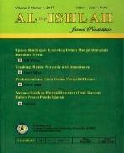

The Role Of Organizational Culture And Lecturer Creativity In The Development Of Student Organizational Citizenship Behavior

Griet Helena Laihad¹, Purnama Pasande²

DOI: Universitas Pakuan Bogor, Indonesia

Article Info | Abstract
Keywords:  Organizational Citizenship Behavior, Organizational Culture, Lecturer Creativity  Kata kunci:  Perilaku Kewarganegaraan Organisasi, Budaya Organisasi, Kreativitas Dosen | Management researchers have linked Organizational Citizenship Behavior (OCB) to individual success in organizational settings but only a few articles concerning student OCB have all been conducted amongst college and university students. This study is to explored the concept OCB in relation to undergraduate college students and examines the role of organizational culture and lecturer’s creativity toward student’s OCB in College. Data were collected from 104 students at private College in Luwuk Banggai . The method of data processing using regression analysis and Structural Equation Modeling (SEM). The result indicated that Organizational culture with dimensions of attention to details and lecturer creativity with dimension of flexible and spontaneous thinking, is the most influential in student’s OCB with dimension of initiative in the College. Therefore, it could be concluded that in developing student’s OCB, organizational culture and lecturer creativity should be taken into consideration.  Abstrak  Peneliti manajemen telah menghubungkan Perilaku Kewarganegaraan Organisasi (Organizational Citizenship Behavior/OCB) dengan keberhasilan individu dalam pengaturan organisasi tetapi hanya beberapa artikel tentang OCB mahasiswa yang semuanya telah dilakukan di kalangan mahasiswa dan mahasiswa. Penelitian ini untuk mengeksplorasi konsep OCB dalam kaitannya dengan mahasiswa sarjana dan mengkaji peran budaya organisasi dan kreativitas dosen terhadap OCB mahasiswa di Perguruan Tinggi. Data dikumpulkan dari 104 mahasiswa di Perguruan Tinggi Swasta di Luwuk Banggai. Metode pengolahan data menggunakan analisis regresi dan Structural Equation Modeling (SEM). Hasil penelitian menunjukkan bahwa Budaya organisasi dengan dimensi perhatian terhadap detail dan kreativitas dosen dengan dimensi berpikir fleksibel dan spontan, paling berpengaruh dalam OCB mahasiswa dengan dimensi inisiatif di Perguruan Tinggi. Oleh karena itu, dapat disimpulkan bahwa dalam mengembangkan OCB mahasiswa perlu diperhatikan budaya organisasi dan kreativitas dosen.

INTRODUCTION
Character building is a key factor in developing the quality of education especially in the era of educational 4.0 and 21st century learning. Higher education is expected to produce graduate students who not only have intellectual intelligence but especially have good character. This character will be the basis in developing knowledge that is beneficial to humanity.
The character embodied in the behavior of mutual help, tolerance, having individual initiative, willing to develop themselves, adhere to applicable regulations and loyal to the organization is a characteristic of Organizational Citizenship Behavior (Laihad G.H, 2018; Podsakoff,et al.,2000; Jahangir,et.al., 2004 ) . Students who have high OCB will be an asset for the country in having a smart and high-quality young generation. Students will be sensitive to the needs of friends and the environment who need help, will be able to avoid conflict and even become a peacemaker because they have a high tolerance for others. Students will also have high initiative in facing the era of educational 4.0, able to develop themselves without having to depend on other parties. Students also care about the continuity of Higher Education by taking part in campus development. Students also will voluntarily abide by the rules of Higher Education and have a sense of ownership and pride in their University. Thus OCB is more behavior than expected standards (Laihad G.H, 2019; Calquitt, et.al., 2009; Mac Shane, et.al., 2008).
In fact there are still many cases related to student tolerance (Juwita, 2018; Wilde, et.al., 2012; Siregar, 2019), Academic Behavior Cheating (Elana Era, 2019), individual initiative (May, 2018; Stelnicki et.al., 2015) and self-development (Mesarosova, 2017). This indicates that OCB is still low among students.
High OCB can be achieved if there is a conducive organizational culture (Laihad G.H, 2018; Aldrin, 2019; Shane P. Desselle, 2017). By understanding the organizational culture in the campus environment, students will act more directedly. In addition, high OCB can be achieved if there are creative instructors in providing learning (Blazar & Kraft, 2017) so that students have individual initiative as a provision in facing the millennial era.
The dimensions and indicators of OCB are as follows: 1) help, 2) tolerance, 3) Individual Initiative, 4) Self-Development, 5) social morals, 6) compliance, 7) loyalty (Callquitt, et.al., 2009; Robbins, 2009; Greenberg, 2008; Podsakoff, 2000; Laihad G.H, 2019). Previous research shows that there is a positive influence between OCB and organizational culture (Laihad G.H, 2018; Aldrin, 2019), so the higher the organizational culture, the higher OCB. Likewise in the case of teacher creativity, the higher the creativity of teaching will affect their attitudes and behavior (Blazer & Kraft, 2017).
Facing the educational era 4.0, high OCB is needed because the challenges ahead require young generations who have, among others 1) Communication skills, 2) creativity for sustainable solutions, 3) Technology skills, 4) collaborative work (in teams), 5 ) tolerance for ambiguity, 6) compliance (Heckla7u et al, 2016) .
From the foregoing, researchers are interested in further researching on whether OCB can be developed through student organizational culture and lecturer creativity?
METHODS
This research uses quantitative research methods by distributing Organizational Citizenship Behavior (OCB) instruments, Organizational Culture and creativity via online. The population of respondents from this study were 169 students and the number of samples based on the Slovin formula were 118 respondents. From the sample of 118 respondents, 104 respondents can be used, it means that the number of samples in this study is 104 respondents.
The quantitative data obtained were analyzed using SEM analysis technique using Lisrel 8.7, testing normality, interpreting the results of testing of measurement models and Structural models, overall model goodness of fit test. It is expected that the dominant factors of organizational culture and lecturer creativity can be found that can enhance student OCB.

RESULTS AND DISCUSSION

Table 6 Normality Test Results based on Questionnaires
No | Indicator | P-Value | Description
1 | X1 | 0,47 | Normal
2 | X2 | 0,47 | Normal
3 | X3 | 0,41 | Normal
4 | X4 | 0,61 | Normal
5 | X5 | 0,29 | Normal
6 | Y1 | 0,58 | Normal
7 | Y2 | 0,81 | Normal
8 | Y3 | 0,85 | Normal
9 | Y4 | 0,91 | Normal
10 | Z1 | 0,64 | Normal
11 | Z2 | 0,67 | Normal
12 | Z3 | 1,09 | Normal
13 | Z4 | 1,01 | Normal
14 | Z5 | 0,84 | Normal
15 | Z6 | 0,78 | Normal
16 | Z7 | 0,64 | Normal

The table above shows the results of the univariate normality test from the questionnaire data. In this study is linear where the F value has a significance ≥0.05, for the normality test performed using Lisrel 8.7 which shows normality on all indicators univariately because it shows a p-value> 0.05 at the level of α = 0.05.
Table 7 Cut-off guidelines for interpreting the results of testing the measurement model and structural model

 | Type of Testing |  | Criteria | Value  Cut-off | Desecription
Measurement Model Analysis
1. | Validity test |  | Standardized Factor Loading (SFL)  t-value | ≥ 0.50  ≥ 1.96 | Valid  Valid/ Significant
2. | Match Test  Whole  Model (Good-  Ness of Fit) |  | p-value of χ²  RMSEA  NFI  NNFI  RFI  CFI  IFI  Standardized RMR  GFI  AGFI | ≤ 0.05  ≤ 0.08  ≥ 0.90  ≥ 0.90  ≥ 0.90  ≥ 0.90  ≥ 0.90  ≤ 0.05  ≥ 0.90  ≥ 0.90 | (good fit)  (good fit)  (good fit)  (good fit)  (good fit)  (good fit)  (good fit)  (good fit)  (good fit)  (good fit)
3. | Reliability Test |  | Construct Reliability (CR)  Variance Extracted (VE) | ≥ 0.70  ≥ 0.50 | Good reliability  Good reliability
 |  | Structural Model Analysis
1. | Overall Fit Test  Model (Good-  Ness of Fit) |  | Same as above
2. | Analysis  Connection  Causal |  | t-value and Coefficient of Structural Equation  Coefficient of Determination (R²) | ≥ 1.96 (absolute value) = Significant  The number R2 indicates that the exogenous latent variable  Explain the % variance  Against endogenous latent variables  R²< 0.2 = weak  R² between 0.2 and 0.5 =  currently; R²> 0.5 = strong  (Sridharan et al., 2012)
Source: Wijanto (2008)

Table 8 (goodness of fit test) overall model
GOF | Cut off Value | Value of research result | Description
Chi-square (χ²) | preferably smaller than | 97.49 | Pretty good: fit
Df |  | 84 | Pretty good: fit
Chi-square  ( χ² )/df | ≤ 3  (2:1 (Tabachnik and Fidell, 2007) and  3:1 (Kline, 2005)) | 1.16 | Good : good fit
Probability (P-value) | ≤ 0,05 | 0.149 | Good : good fit
RMR | Good models have small RMR (Tabachnik and Fidell, 2007), ≤ 0,05 or 0,08 (Hair 2007) | 0.0808 | Good :goodfit
RMSEA | ≤ 0,08 | 0.04 | Good :goodfit
GFI | ≥ 0,90 | 0.884 | Good : good fit
AGFI | ≥ 0,90 | 0.834 | Good : good fit
CFI | ≥ 0,90 | 0.978 | Good : good fit
NFI | ≥ 0,90 | 0.905 | Good : good fit
NNFI | ≥ 0,90 | 0.972 | Good : good fit
RFI | ≥ 0,90 | 0.881 | Good : good fit
IFI | ≥ 0,90 | 0.978 | Good : good fit

In order to find out whether a proposed measurement model is fit or not with data, then the measurement model suitability testing is carried out. A measurement model can be called fit with data if the model can estimate the data covariance matrix. The size of fit is indicated by the size of Chi-squared (χ2) / df≤ 3. The processed data is produced that the Chi-squared value (χ2) / df = 1.16. This means that the measurement model is fit (very good). Other factors that determine the size of the godness of fit test (GOF) such as CFI values ​​greater than 0.90, P-count Chi-squared statistics produced by the model is greater or equal to 0.05 where the model is in good category because the P- value the count is 0.12 or the RMSEA value is less than 0.08

Figure 3: t-count Equation Test Results
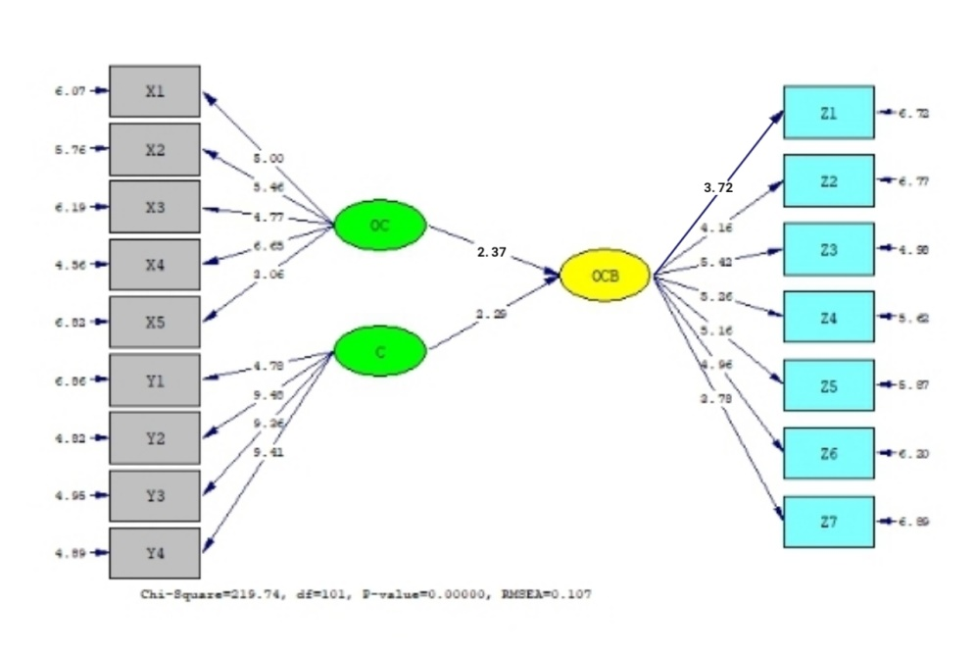

Figure 4. t-value equation test results (regression coefficient)
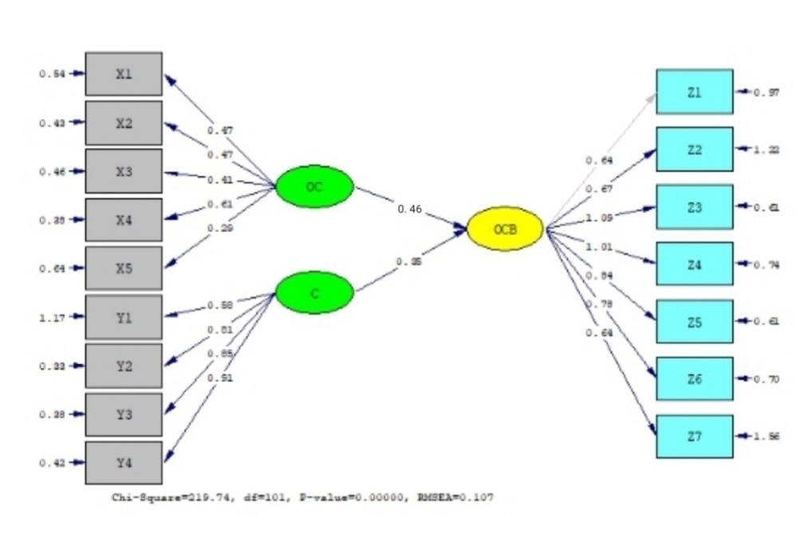
INFLUENCE | COEFFICIENT REGRESSION | t-  COUNT | t-TABLE | RESULT | CONCLUSIONS
OC – OCB | (0,46)² = 0,2116 | 2,37 | 1,96 | t-count > t-table | Positive affect
C – OCB | (0,35)² = 0,1225 | 2,29 | 1,96 | t-count < t-table | Positive affect

STRUCTURAL EQUATION MODEL
OCB = 0.46*OC+0.35*C, Errorvar.=0.15,R² = 0.85

2.37 2.29 26.77

- Organizational Culture influences Organizational Citizen Behavior (OCB) with a regression coefficient of 0.46 and t-count 2.37> 1.96. The dimension that reflects Organizational Culture is the Dimension of Attention to detail, with a Standard Loading Factor value of 6.65.
- Creativity affects the Organizational Citizen Behavior (OCB) with a regression coefficient of 0.35 and t-count 2.29> 1.96. The dimension that reflects Creativity is the dimension of flexible and spontaneous thinking, with a Standard Loading Factor value of 9.48.
- Organizational Culture and Creativity together affect the Organizational Citizen Behavior (OCB) with a calculated F value of 26.77> F table 3.04.
- The dominant variable affecting OCB is Organizational Culture variable with a regression coefficient that is 0.46 greater than Creativity with a regression coefficient of 0.35.
- Furthermore, the contribution of exogenous variables (Organizational Culture and Creativity) to OCB is R² = 0.85 or 85%, while the remaining 0.15 or 15% is contributed by other variables not examined.

CONCLUSION
Based on the results of the study it can be concluded that dominant factors in orgaization culture which can increase student OCB is gives attention to details to students such as having a group discussion schedule, carrying out analysis and evaluation in each learning and giving rewards to outstanding students. Besides that, in the creativity of lecturers, the most dominant factor is giving flexible and spontaneous thoughts such as accepting new things and input from students to improve learning, reflecting at the end of learning, conveying ideas in detail and clearly and confidently in making decisions.
Therefore, in enhancing OCB, especially to improve individual dimension of student initiatives, is can be done through enhancing organizational culture and lecturer creativity, especially on dominant factors.
REFERENCES

Aldrin and Yunanto, 2019, Job Satisfaction as a Mediator for the Influence of Transformational Leadership and Organizational Culture on Organizational Citizenship Behavior, Psychology Journal 12, 126-134, 2019
Blazar & Kraft, 2017, Teacher and Teaching Effects on Students’ Attitudes and Behaviors. Educ Eval Policy Anal. 2017 Mar; 39(1); 146-170
Colquitt et al. Organizational Behavior:Improving Performance and Commitmet in the Workplace. New York:McGraw-Hill, 2009.
Desselle S.P, Perception of organizational culture amd organizational citizenship by faculty in U.S. college and schools of pharmacy, jounal homepage: www.elsevier.com/locate/cptl
Elana Era, 2019, Perilaku Kecurangan Akademik, Equity Vol.22., No.2,2019,185-196
Greenberg, J. & R. A. Baron. Behavior in Organizations. New Jersey: Pearson, 2008.
Hecklau F et al, Holistic Approach for Human Resource Management in Industri 4.0. 1-6, Conference on Learning Factories, 2016
Juwita et al, Students’ Tolerance Behavior in Religious-Based Primary School:Gender Prospective. International Journal of Education Research Review, online 01.07.2018
Jahangir et.al, Organizational Citizenship Behavior: Its Nature and Antecedents, BRAC University Journal, vol.1 no. 2, 2004, pp. 75-85
Laihad, Griet Helena & Retnowati, 2018, The Effect of Organizational Culture And Decision Making Toward Organizational Citizenship Behavior of Teacher in Pre-School, Journal of Education, Teaching and Learning, volume 3 Number 1 March 2018. Page 155-158
Laihad, Griet Helena. 7 Perilaku Guru Extraordinary .Jakarta: PT. Inkubator Penulis Indonesia, page 3-6, 2019
Laihad, Griet Helena and Henny Suharyati, Enhancing Organizational Citizenship Behavior by Strengthening Leadership Style and Decision Making, International Journal of Recent Technologyand Engineering (IJRTE), 2019.
Mei & Luluk, 2018 Perilaku Malas Belajar di Lingkungan Kampus, Journal trunojoyo.ac.id
Mesarosova, Margita, Care for Self-Development in Relation to the Self-Regulation in Students of Heping Professions, International Journal of Social Sciences, ISSN 24545899, Vol 3 Issue 1, pp.586-596, 2017
Podsakoff, P.PM. “Organizational Citizenship Behavior:a critical Review of The theoretical Empirical literature and Sugestions for Future Research”. Jurnal of Management, 2000.
Siregar, W.A. Mahasiswa Tawuran di Area Kampus, Satu Orang Tewas Ditikam. News.okezone.com
Robbins, S. P. & T. A. Judge. Organizational Behavior. New Jersey: Pearson Education, 2009.
Stelnicki, Andrea M & David W. Nordstokke, Who Is the Succesful University Student? An Analysis of Personal Resources, Canadian Journal of Higher Education, Vol. 45, No. 2, 2015, pp. 214-228
S. L. McShane and M. A. Von Glinow.Organizational Behavior. New York: McGraw- Hill, 2008.
Narayanan, Selvi, A Studi on the Relationship between Creativity and Innovation in Teachingg and Learning Methods towards Students Academic Performance at Private Higher Education Institution, Malaysia,International Journal of Academic Research in Business and Social Sciences, Vo. 7, Special Issue-4th International Conference on Educational Research and Practice, 2017
Wilde, Jerry, The Relationship between Frustration Intolerance and AcademicAchievement in College, International Journal of Higher Education, Vo. 1 No. 2, 2012

