Applications Based Learning Effectiveness of Media in Improving Basic Skills Students Table Tennis

Samsuddin Siregar¹, Eva Faridah², Rosmaini Hasibuan³
¹Univeristas Negeri Medan, Indonesia
Email: samsuddinsiregar@unimed.ac.id
²Univeristas Negeri Medan, Indonesia
Email: evafaridah@unimed.ac.id
³Univeristas Negeri Medan, Indonesia
Email: rosmainihsb02@gmail.com

ARTICLE INFO |  | ABSTRACT
Keywords:  Learning Media  Application-Based  Table Tennis Skills |  | This study aims to test the effectiveness of application-based learning media in improving basic table tennis technical skills. The sample in this study involved students consisting of two groups, namely the experimental group of 15 people and the control group of 15 people. The research was carried out online, this was because it was still in an emergency due to the Covid-19 pandemic. The method used in this study is an experimental method with the aim of seeing the difference in skill levels of the two research groups. The data collection technique used is through performance tests and online observations. Then the data were analyzed by calculating the percentage. The results of data analysis obtained through skill performance tests, it can be seen that the level of basic table tennis technical skills in the experimental group and the control group both have good results. However, if you look at the comparison of the percentage levels obtained by the two groups, it can be seen that the experimental group has a higher percentage of skill level compared to the control group. the experimental group is a group whose learning activities use application-based learning media. Based on the results of the research above, it can be concluded that online learning using application-based media can improve students' understanding and skills in basic table tennis technical material.
Article history:
Received 2021-08-14
Revised 2021-11-12
Accepted 2022-01-17
 |  | This is an open access article under the CC BY-NC-SA license.
Corresponding Author:
Samsuddin Siregar
Affiliation 1; e-mail@e-mail.com
Univeristas Negeri Medan, Indonesia
samsuddinsiregar@unimed.ac.id

INTRODUCTION
Table tennis is one of the subjects that must be taken by students studying in the Health and Recreation Physical Education Study Program, Faculty of Sports Science, State University of Medan. The unit credit for this course is 2 credits and students must pass the course as one of the requirements for obtaining a bachelor's degree in sports education. The content of the course material consists of the essence of table tennis, history of table tennis, basic tablerules, tennis techniques, table tennis game, and table tennis teaching techniques. Ideally, all of these material content should be mastered by students and able to apply them so that students can be said to be competent in this course.
Table tennis is one of the most popular sports in the community, in schools as well this sport is a type of sport that is in great demand by students, so many physical education teachers make this sport a choice of sports games given to students. Due to the high interest of the community and students in schools towards this sport, table tennis is one of the sports that must be mastered by students as prospective physical education teachers. a small ball is hit back and forth using a bet on the table, until someone makes a mistake to score.
During the Covid-19 pandemic, the learning implementation system in Indonesia changed completely, including in various universities. Usually learning is carried out face to face, lecturers and students can directly interact, discuss, simulate, in the lecture process. However, due to the Covid-19 pandemic, learning is carried out without face-to-face, in the sense that learning is carried out remotely, so that lecturers and students cannot meet directly in carrying out lectures. As a result of this distance learning makes students and lecturers overwhelmed in carrying out table tennis lessons. Using the media zoom meet, google meet and goggle classroom as the media used was not easy to make students understand the material being taught.
Based on the results of observations made on students who have passed the table tennis course during lectures during the COVID-19 pandemic in the Health and Recreation Physical Education Study Program, many students cannot be categorized as competent. The results of the observations can be seen in the following diagram.

Figure 1. Percentage of Student Competency Level in Table Tennis
Course The diagram above describes a description of student competence in table tennis. During the Covid-19 pandemic, only 10% are in the very good category, 30%, and the sufficient category is 60%. The competence category is basically sufficient to have unreliable knowledge, as a prospective physical education teacher, of course, with sufficient competence, it is still not feasible to teach table tennis material. To be able to teach table tennis material, at least students have good competence. This condition makes researchers worry and want to help students and lecturers overcome the problems they face. One of the efforts made is to develop an application-based table tennis learning video media. This table tennis learning video can be used as a source of teaching materials for students to learn various table tennis materials. And during the Covid-19 pandemic, practical material was one of the most difficult materials for students to master, so through videos that were made and following the instructions, students could study independently. The video media can be accessed from the developed application and the lecture process is also carried out through the application. Various researches on the development of learning videos have been carried out previously by other researchers and the results are very good in influencing the learning process, student learning motivation so that competence can be increased. Based on this condition, the researcher wants to improve the basic technical skills of table tennis students through learning by using video teaching materials based on web applications.
This opinion explains that for every mistake there must be points, the accumulated points obtained determine the victory of each player. Furthermore (Mc.Afee Richard, 2009), also defines the game of table tennis from a physical aspect, saying that this sport is a type of sport that requires a combination of explosive power from the feet and fine motor skills in the hands. Based on the definition of table tennis that has been put forward by the experts above, the researchers can conclude that table tennis is a sport of hitting the ball using a bet on the table through the ability to combine good foot and hand movements (Siregar et al., 2019). To be able to play table tennis is certainly not something that is easy to do, it takes seriousness to learn and practice. Various things that need to be mastered by someone who wants to play table tennis, must master the techniques that exist in this sport. The basic technique is a technique punch drive, stroke technique push, stroke technique block, stroke technique smash, blow technique, spin, stroke technique servicing, stroke technique halley volley, stroke technique side slip shot, stroke technique loop, stroke technique flip, stroke technique drop shot, punch technique loband punch technique chop (Mc.Afee Richard, 2009).
The role of media in learning can be likened to how important lighthouses are in the aviation system (Siregar et al., 2022). Media is a guide to facilitate access to information so that it reaches students appropriately. Theoretically, the function of the media can be grouped into three, namely:
a) Increasing the productivity of the learning messages presented, because it can accelerate students' understanding of the material in question, so that directly help use time effectively, and lighten the burden of teachers who concerned.
b) Helping learners develop the ability of learners' mental activities to understand the message according to the power of analysis. The development of this analytical and reasoning power is a learning function.
c) Helping learners to be creative in planning their educational programs, so that the development of learning messages can be well designed
d) Help integrate learning messages with closely related auxiliary science materials relation to the learning material presented. For example, how to behave to society, to the environment and so on.
e) Helping learners convey learning messages in a principled manner or consistent, because the subject matter does not deviate from what has been programmed and can be completely replayed. This will be different if the messages of learning materials delivered through the lecture method (Muhammad Ramli, 2021).
The media developed should be useful in accordance with the expected goals. A media has usefulness if the media can be a source of learning that can stimulate the various senses of students (Kasih et al., 2022). In the sense that the more senses involved in observing the media, the more information students will get. Thus, quality media must be developed in accordance with the principles of media development. According to (Mukminan, 2004) there are several principles of media creation that need to be considered by developers, namely media must be visible, interesting, simple, useful, accurate, legitimate, and structured. According to (Cheppy Riyana, 2007) ideally video media should be able to generate motivation, thus video media need to bring up characteristics, namely video is able to enlarge objects that are small or too small that cannot be seen by the naked eye, video is able to manipulate image display according to message demands. What you want to convey is that videos are able to turn objects into still pictures, meaning that objects can be stored for a certain duration, in silence, the attractiveness of videos is that they can keep students' attention longer for up to 1-2 hours to listen to videos compared to just listening which only lasts 25-24 hours. 30 minutes, the video is able to display the most recent, warm, current or current image objects and information.
The nature of e-learning as explained by (Zou et al., 2012) that the use of e-learning in the context of learning there are 2, namely benefits from the point of view of students and benefits from the point of view of the educator. From the student's point of view, it will make the learning activities carried out more dynamic and flexible, so that wherever students have the opportunity to access more material. Furthermore, it is said to be dynamic and flexible, meaning that students in establishing teaching and learning interactions with educators can realize an agreement at any time. Then from the educator's point of view, the existence of e-learning can make educators wider in providing learning resources for their students, controlling the learning behavior of their students both in the learning process and in the evaluation process. E-learning is a learning system that is feasible to be applied and developed in learning, both in conventional learning and in distance learning. However, it should be noted by educators that in utilizing the e-learning system, it is necessary to minimize the various weaknesses that exist, so that the nature and objectives of learning can still be achieved optimally. The table tennis course is a practical course that aims to provide educational services to students so that they can understand and teach table tennis through their skills or competencies. In achieving this goal, the role of media and learning applications is an important thing during the COVID-19 pandemic and also in learning that adheres to the distance education process. However, it should be noted that in determining the appropriate learning media and applications, it is of course adapted to the learning objectives, adapted to the characteristics of students and the basic motion elements of table tennis.

METHOD
This research was conducted on students of the Health and Recreation Physical Education Study Program. The location of this research was carried out at the Faculty of Sports Science, State University of Medan from August 2021 to September 2021. The method used in this study was a quasi-experimental method to see the effectiveness of video media based on learning web applications in improving basic table tennis technical skills of Study Program students (Sugiyono, 2016). Physical Education, Health and Recreation. This study involved two treatment groups, namely the experimental group and the control group. The experimental group is a group that learns table tennis using application-based video media, and the control group is a group that learns table tennis in a conventional way. The following is the design of a quasi-experiment:

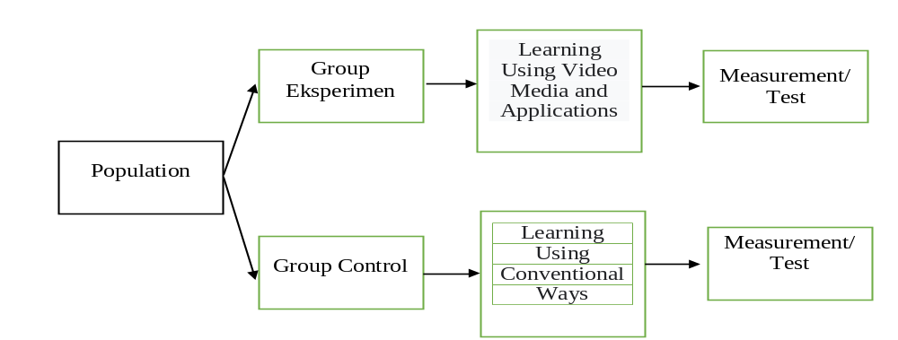
Figure 2. Quasi Experimental Design

The Data collection technique of this research was conducted through tests and observations. The test was conducted to measure the level of students' basic table tennis skills using a performance test sheet. This test sheet is used by officers to assess the correctness of the movements displayed by students during the test. Then observations are made to collect facts hat occur when learning is carried out, this is used as material for process evaluation. Furthermore, this research data analysis technique uses quantitative analysis to see the relationship between variables, the formula is as follows:
The scenario for the implementation of learning for the two groups was carried out online for 8 meetings, each meeting took 90 minutes. For the experimental group, the table tennis learning is carried out with the lecturer through the web application http://learningtenismeja.com/. All students join to enter the web using their respective passwords. The implementation of learning begins after lecturers and students have joined the web. The approach used in this study is a scientific approach starting from the stages of observing, asking, trying, gathering information and communicating. The following is a display of the application used in the experimental group learning, various table tennis materials and video tutorials have been input into the application and students can access it to learn it.
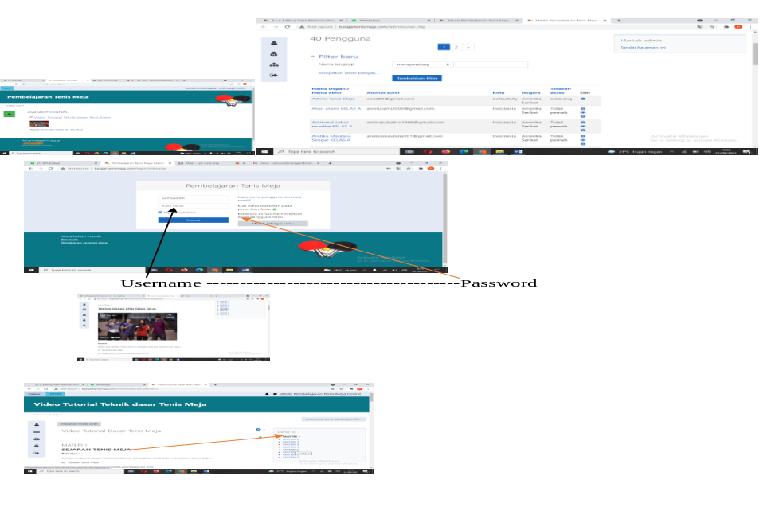
Figure 3. Applications Used by Experimental Groups in Learning Table Tennis

RESULT AND DISCUSSION
Result
Five basic table tennis techniques that are the subject of this effectiveness test are the basic techniques of forehand serve, backhand serve, forehand drive, backhand drive and top spin. These five basic techniques were tested for skills at the Medan State University campus by being observed by the assessor using a process assessment instrument. The results of the assessment of students' basic table tennis skills are described as follows:
- Basic forehand service technique skills in the experimental group and the control group

Figure 4. Comparison Diagram of Experimental Group Forehand Service Skills and Control Group

Based on the diagram above, it can be seen that there are differences in the level of basic forehand servicing skills of the experimental group and the control group. The difference is seen from the average obtained by the two groups. The average gain of the experimental group for the preparation stage was 96.9, the implementation stage was 98.6 and the final stage was 95.6. Meanwhile, the average acquisition of the control group for the preparation stage was 90.6, the implementation stage was 82.9 and the final stage was 83.1. Based on the average gain, it can be seen that the experimental group is higher than the control group. Thus it can be concluded that the implementation of the experimental group learning that was given online learning treatment using video media and applications was better, compared to the control group (conventional).
- Basic technical skills of backhand serving in the experimental group and the control group

Figure 5. Comparison Diagram of Backhand Service Skills Experiment Group and Control Group

Based on the diagram above it can be seen the difference in the level of basic backhand service technique skills in the experimental group and the control group. The difference is seen from the average obtained by the two groups. The average gain of the experimental group for the preparation stage was 91.9, the implementation stage was 86.4 and the final stage was 82.5. Meanwhile, the average acquisition of the control group for the preparation stage was 83.8, the implementation stage was 79.6 and the final stage was 76.3. Based on the average gain, it can be seen that the experimental group is higher than the control group. Thus, it can be concluded that the implementation of the experimental group learning which was given online learning treatment using video media and applications was better, compared to the control group (conventional).
- Basic forehand drive technique skills in the experimental group and the control group

Figure 6. Comparison Diagram of Forehand Drive Skills Experiment Group and Control Group

Based on the diagram above it can be seen the difference in the level of basic forehand drive technique skills of the experimental group and the control group. The difference is seen from the average obtained by the two groups. The average gain of the experimental group for the preparation stage was 96.9, the implementation stage was 91.3 and the final stage was 88.1. Meanwhile, the average acquisition of the control group for the preparation stage was 86.3, the implementation stage was 78.1 and thestage was final 81.3. Based on the average gain, it can be seen that the experimental group is higher than the control group. Thus, it can be concluded that the implementation of the experimental group learning which was given online learning treatment using video media and applications was better, compared to the control group (conventional).

- Basic technical skills backhand drive experimental group and control group

Figure 7. Comparison Diagram of Backhand Drive Skills of Experimental Group and Control Group

Based on the diagram above, it can be seen that there are differences in the level of basic backhand drive technique skills of the experimental group and the control group. The difference is seen from the average obtained by the two groups. The average gain of the experimental group for the preparation stage was 90.6, the implementation stage was 89.1 and the final stage was 81.9. Meanwhile, the average acquisition of the control group for the preparation stage was 87.5 for the implementation stage, 83.8 and for the final stage, 74.4. Based on the average gain, it can be seen that the experimental group is higher than the control group. Thus, it can be concluded that the implementation of the experimental group learning which was treated with online learning using video media and applications was better, compared to the control group (conventional).
- Basic technical skills top spin experimental group and control group

Figure 8. Comparison Diagram of Top Spin Skills Experiment Group and Control Group

Based on the diagram above, it can be seen the difference in the level of basic top spin technique skills between the experimental group and the control group. The difference is seen from the average obtained by the two groups. The average gain of the experimental group for the preparation stage was 92.5, the implementation stage was 88.1 and the final stage was 81.9. Meanwhile, the average acquisition of the control group for the preparation stage was 89.4 for the implementation stage, 82.2 and for the final stage, 78.8. Based on the average gain, it can be seen that the experimental group is higher than the control group. Thus, it can be concluded that the implementation of the experimental group learning which was given online learning treatment using video media and applications was better, compared to the control group (conventional).

DISCUSSION
The development of learning by making learning innovations is an important thing for an educator to do (David C.D. van Alten *, Chris Phielix , Jeroen Janssen, 2020). It is seen from the results of the research above, it is evident that the innovation of video-based teaching materials given to students in table tennis learning has given good results. As previously explained, the videos developed in this study contain material content and various video tutorials on the practice of basic table tennis techniques (servicing techniques, drive techniques and spin techniques). Based on the results of trials that have been carried out in learning, the videos developed have been able to assist students in learning various table tennis materials and through these videos can also be a source of knowledge and models for students in honing their skills. There are 3 advantages that are the reason the video can help students learn table tennis material, namely: (1) The video media developed is easy for students to access from the e-learning application that has been developed, (2) The video media developed is presented with tutorials. the movements are systematic and presented in slow motion, (3) the movements shown in the developed videos are equipped with simple text displays and are equipped with systematic explanations so that the meaning of each movement can make it easier for students to understand them.
For educators learning table tennis is something that is not easy to teach to students because not all students have good skills (Wolf et al., 2015). For students whose skills are still beginners, of course it is necessary for educators when carrying out learning to provide intervention models, media, aids, teaching materials, and class management that are in accordance with the characteristics of students, including video-based teaching materials (Palao, 2012). So far, video-based teaching materials can still be ascertained as effective and interesting teaching materials to be presented during class learning (Hee Jun Choi, 2005). Because presenting the right video in the learning process will be able to stimulate the reasoning power of students when watching videos (Balasubrmaniam Gayathria Raksha Vedavyas P.Sharanya K.Karthik, 2021).
Apart from the video products described above, this research also produces development products in the form of applications. This application developed is an application that can be used as a forum for online learning spaces between educators and students. This application was developed based on the needs and conditions of the covid-19 outbreak, which has made learning impossible to do face-to-face. Based on the results of product development and testing, as described above, this application is suitable to be used as a table tennis learning media that is carried out online. During the application of this product in learning, it is proven that all students who are the subject can easily access this application both when logging in and in using the menus in this application. Based on the responses of students and lecturers to the developed application, it has five advantages; (1) This application provides convenience for students and lecturers in conducting online learning or distance learning, (2) This application is an application developed specifically for table tennis, so this application is easier to access, (3) Through this application students are more easy to understand various table tennis material from the Material Menu. Because the Material Menu has presented in detail the material and tasks that students can do systematically, (4) Through this application, lecturers can more easily convey various table tennis materials by entering them into the Material Menu. (5) Applications can be accessed by students anytime and anywhere.
The use of web applications as a medium in learning is an important aspect in the current era (Ehsan Soleimania, Kemboja Ismail, 2014). Then Jimmi also emphasized that distance learning, blended learning makes students and lecturers carry out learning activities without having to face to face (Jimmi Copriady, 2015). (Haug & Mork, 2021)in the 21st century education has been disrupted, the digitalization of education has made all human resources in the educational environment have to adapt to the times, serving by utilizing current technological developments is something very important. Likewise with educators in teaching, media, methods, models and involving technology are components that must be used in learning so that students are familiar with the technology and knowledge they want to find quickly (A, Rea Lavi & Dori, 2021). Several studies that have developed web applications in learning practices have also been carried out and felt the benefits by (MichelaBarisone, 2019).

CONCLUSION
Based on the results of the research and discussion above, it can be concluded that learning table tennis using web-based video media is better than learning table tennis using conventional methods in improving basic table tennis technical skills for students of the Physical Education Study Program. Health and Recreation, Faculty of Sports Science, State University of Medan in 2021.

REFERENCES
A, Rea Lavi, M. T. b, & Dori, Y. J. (2021). Perceptions of STEM alumni and students on developing 21st century skills through methods of teaching and learning. Studies in Educational Evaluation, 70, 0191–0491. https://doi.org/https://doi.org/10.1016/j.stueduc.2021.101002
Balasubrmaniam Gayathria Raksha Vedavyas P.Sharanya K.Karthik. (2021). Effectiveness of reflective learning in skill-based teaching among postgraduate anesthesia students: An outcome-based study using video annotation tool. Medical Journal Armed Forces India, 77(1), S202–S207. https://doi.org/https://doi.org/10.1016/j.mjafi.2020.12.028
Cheppy Riyana. (2007). Pedoman Pengembangan Media Video. Program P3Ai Univeristas Pendidikan Indonesia.
David C.D. van Alten *, Chris Phielix , Jeroen Janssen, L. K. (2020). Self-regulated learning support in flipped learning videos enhances learning outcomes. Computers & Education, 158(104000). https://doi.org/https://doi.org/10.1016/j.compedu.2020.104000
Ehsan Soleimania, Kemboja Ismail, R. M. (2014). The Acceptance of Mobile Assisted Language Learning (MALL) among Post Graduate ESL Students in UKM. Social and Behavioral Sciences, 118, 457 – 462. https://doi.org/doi: 10.1016/j.sbspro.2014.02.062
Haug, B. S., & Mork, S. M. (2021). Taking 21st century skills from vision to classroom: What teachers highlight as supportive professional development in the light of new demands from educational reforms. Teaching and Teacher Education, 100(103286). https://doi.org/ttps://doi.org/10.1016/j.tate.2021.103286
Hee Jun Choi. (2005). The Effect of Context-Based Video Instruction on Learning and Motivation in Online Courses. American Journal of Distance Education, 19(4). https://doi.org/10.1207/s15389286ajde1904_3
Jimmi Copriady. (2015). Self- motivation as a mediator for teachers’ readiness in applying ICT in teaching and learning. Procedia - Social and Behavioral Sciences, 176, 699 – 708. https://doi.org/doi: 10.1016/j.sbspro.2015.01.529
Kasih, I., Faridah, E., Siregar, S., Bangun, S. Y., & Sinulingga, A. (2022). Effectiveness of Sensor-Based Media to Improve Referee Education. International Journal of Education in Mathematics, Science and Technology, 10(2), 391–408. https://doi.org/10.46328/ijemst.2248
Mc.Afee Richard. (2009). Table Tennis : Steps To Success. Human Kinetics Inc.
MichelaBarisone, E. (2019). The effectiveness of web-based learning in supporting the development of nursing students’ practical skills during clinical placements: A qualitative study. Nurse Education in Practice, 37, 56–61. https://doi.org/https://doi.org/10.1016/j.nepr.2019.02.009
Muhammad Ramli. (2021). Media dan Teknologi Pembelajaran. IAIN Antasari Press. http://idr.uin-antasari.ac.id/10306/1/BUKU UTUH MEDIA DAN TEKNOLOGI PEMBELAJAR-M.RAMLI.pdf
Mukminan. (2004). Desain pembelajaran. UNY Press.
Palao, J. M. (2012). The impact of video technology on student performance in physical education. Technology, Pedagogy and Education, 24(1), 51–63. https://doi.org/https://doi.org/10.1080/1475939X.2013.813404
Siregar, S., Dlis, F., Hanif, A. S., Tangkudung, J., & Siregar, N. (2019). Learning model developing of basic technique for three-dimensional table tennis punch drive for beginner players. International Journal of Recent Technology and Engineering, 8(2 Special Issue 9), 38–43. https://doi.org/10.35940/ijrte.B1009.0982S919
Siregar, S., Kasih, I., & Pardilla, H. (2022). The Effectiveness of E-Learning-Based Volleyball Service Video Media on Students Affected by Covid-19 at Faculty of Sports Science, Universitas Negeri Medan. Teorìâ Ta Metodika Fìzičnogo Vihovannâ, 22(1), 7–13. https://doi.org/10.17309/tmfv.2022.1.01
Sugiyono. (2016). Metode Penelitian dan Pengembangan. CV.Alfabeta.
Wolf, S., Brölz, E., Keune, P. M., Wesa, B., Hautzinger, M., Birbaumer, N., & Strehl, U. (2015). Motor skill failure or flow-experience? Functional brain asymmetry and brain connectivity in elite and amateur table tennis players. Biological Psychology. https://doi.org/10.1016/j.biopsycho.2015.01.007
Zou, J., Liu, Q., & Yang, Z. (2012). Development of a Moodle course for schoolchildren’s table tennis learning based on competence motivation theory: Its effectiveness in comparison to traditional training method. Computers and Education, 59(2), 294–303. https://doi.org/10.1016/j.compedu.2012.01.008

