 | Contents list avaliable at Directory of Open Access Journals (DOAJ)  Al-Ishlah: Jurnal Pendidikan  ISSN: 2087-9490 (Printed); 2597-940X (Online)  Journal Homepage: http://www.journal.staihubbulwathan.id/index.php/alishlah | 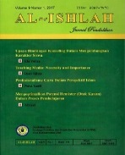

The Use of Ethnomatematics Learning Media Based on Augmented Reality for Junior High School Students
A A Abdullah , T Rochmadi , R Richardo , Nurkhamid , A Wijaya
DOI:
Article Info | Abstract
Keywords:  mathematics learning learning Media  augmented reality  Kata kunci:  pembelajaran matematika  media pembelajaran  augmented reality | This study presents the implementation of augmented reality (AR), for learning geometry mathematics with a cultural approach in junior high schools. The research method used was ADDIE (analysis, design, development, implementation, and evaluation), by limiting it to (1) exploration analysis; (2) design; (3) development; and (4) implementation. By applying the AR concept to the mathematics learning method with a cultural approach, it is hoped that it can create an interesting and fun mathematics learning atmosphere. This is because the application of AR concepts in mathematics learning can help students towards abstract mathematical concepts with the help of 3D objects, as well as improvisation of appropriate sounds and images. This method is expected to be able to answer the main problem of the low mathematics achievement of students in various international assessments such as PISA. The results of the research are an AR application prototype for learning geometric mathematics with a cultural approach in junior high schools, which can be used for geometry material in junior high schools for both classroom and online learning.  Abstrak  Penelitian ini menyajikan implementasi augmented reality (AR), untuk pembelajaran matematika geometri dengan pendekatan budaya di Sekolah Menengah Pertama. Metode penelitian yang digunakan adalah ADDIE (analisis, desain, pengembangan, implementasi, dan evaluasi), dengan membatasi pada (1) analisis eksplorasi; (2) desain; (3) pembangunan; dan (4) implementasi. Dengan menerapkan konsep AR pada metode pembelajaran matematika dengan pendekatan budaya, diharapkan dapat menciptakan suasana pembelajaran matematika yang menarik dan menyenangkan. Hal ini dikarenakan penerapan konsep AR pada pembelajaran matematika dapat membantu siswa menuju konsep matematika yang abstrak dengan bantuan objek 3D, serta improvisasi suara dan gambar yang sesuai. Metode ini diharapkan dapat menjawab permasalahan utama rendahnya prestasi matematika siswa dalam berbagai penilaian Internasional seperti PISA. Hasil penelitian marupakan prototipe aplikasi AR untuk pembelajaran matematika geometri dengan pendekatan budaya di Sekolah Menengah Pertama, yang dapat digunakan untuk materi geometri di sekolah menengah pertama baik untuk pembelajaran di kelas atau daring.

INTRODUCTION
The results of the 2018 Program for International Student Assessment (PISA) survey announced in March 2019 showed that Indonesian students' reading, science, and math skills were still low in the category of reading, science, and math skills, where Indonesia ranked 74th out of 79 countries. Meanwhile, for the category of mathematical ability, Indonesia is ranked 73rd out of 79 countries with an average score of 379. The OECD explains that PISA includes three major components of the mathematics domain, namely context, content, and competence(OCDE, 2019). In accordance with the purpose of PISA to assess students' capacity to solve real problems, the problems in PISA include mathematical content related to phenomena. Problems (and their solutions) can arise from different situations or contexts based on individual experiences(Stacey, 2011). Therefore, the questions given in PISA are presented mostly in real world situations so that the benefits of mathematics can be felt to solve problems of daily life. PISA questions that are non-routine and problem solving problems make Indonesian children have difficulty solving them(Johar, 2012). Difficulties that are often experienced by Indonesian students in solving PISA problems include difficulty in understanding the meaning of the questions, difficulties in relating real-life aspects to mathematical problems (models), difficulties in performing mathematical operations, and difficulties in interpreting the results of mathematical solutions to real-world problems(Haji, 2018). This is because mathematics learning carried out in schools does not get used to solving non-routine and problem solving problems(Safitri, Yasintasari, Putri, & Hasanah, 2020).
On the other hand, the COVID-19 pandemic has changed the learning model in schools. . This situation led to a change in learning that was originally face-to-face in the classroom to online learning at home. During online learning, many students find it difficult to implement it, especially in mathematics(Fauzy & Nurfauziah, 2021). During online learning, smartphones have become an inseparable part of student learning activities. Students are accustomed to using various online media to access various knowledge. So it is impossible to separate smartphones from student learning today, even though learning is carried out face-to-face again. This is because the use of smart phones has become a habit of students at this time(Handayani & Irawan, 2020). So the challenge for mathematics teachers is how to maximize the use of smartphones for learning in schools optimally and effectively. One of the uses of smartphones in learning mathematics is Augmented Reality (AR)(Sudirman, Poppy Yaniawati, Mellawaty, 2021). Augmented Reality (AR) is a technology that combines two-dimensional or three-dimensional virtual objects into a real environment and then projects them in real time(Mustaqim, 2016). AR can also be used to help visualize abstract concepts for understanding and structure an object model. In 1990, the concept of AR was first introduced by Thomas P. Caudell. There are three characteristics that state that a technology can be said to apply the AR concept, namely being able to combine the real world and the virtual world, being able to provide interactive and real-time information, and being able to display it in three dimensions(Aditya, Trisno, Nurwijayanti, & Fitriana, 2018). Utilization of learning media with AR is very useful in improving the learning process and students' interest in learning because AR itself has entertainment aspects that can increase students' interest in learning and playing and projecting it in real terms and involving the interaction of all of the students' five senses with technology(Mustaqim, Pd, & Kurniawan, 2017). this AR. This is because AR has characteristics and functions that are almost the same as learning media, namely the function of conveying information between recipients and senders or educators with students, can clarify the delivery of information provided by educators and students in the learning process, can provide motivational stimulation and interest in learning(W Widada, D Herawaty, 2021).
Based on the problems above, this study aims to describe the development of android-based mathematics learning media using augmented reality technology with an ethnomathematical approach at the junior high school level. The development of this learning media aims to invite students to build mathematical concepts from the real world, using their smartphones with an ethnomathematical approach(Richardo, Martyanti, & Suhartini, 2019). The real world context used in this study is the cultural context, which is a cultural heritage building in Yogyakarta. Meanwhile, the smartphone acts as a bridge between the cultural context and mathematical concepts, which in this case uses augmented reality-based applications.

METHODS
The technique in this study combines Research and Development with the ADDIE model. The researchers conducted interviews with teachers from secondary schools and identified cultural aspects in Yogyakarta that can be used as content to connect the real world to mathematical concepts in this case geometry material. Researchers conducted a search on cultural heritage buildings which include Yogyakarta Palace, The Great Mosque of Kauman, Taman Sari Water Castle, and Ratu Boko Temple. After finding objects related to the concept of geometry, the media development process using the ADDIE model is carried out. The ADDIE model has five stages, namely (1) analysis, (2) design, (3) development, (4) implementation, and (5) evaluation. by limiting it to (1) exploration analysis; (2) design; (3) development; and (4) implementation. The ADDIE method is a method that is widely used in the development of AR learning media. The ADDIE model is widely used because it has several advantages which include more operational, systematic, practical, and more procedural steps. The trial process for implementing the AR Application prototype with an ethnomathematical approach to geometry material for Junior High Schools took a sample of students at MTs As Syalafiyah Mlangi, Sleman, Yogyakarta.
FINDINGS AND DISCUSSION
Analysis Stage
Needs analysis in the mathematics learning process in junior high schools is carried out on planning, implementation, evaluation, and follow-up learning. Based on observations and interviews with teachers in secondary schools in several schools in Yogyakarta, several problems that often occur in the implementation of mathematics learning in junior high schools were found, including: (1) most of the teachers found that there were students who still had difficulties in learning the material. geometry; (2) most mathematics teachers rarely use culture as a learning context; (3) all mathematics teachers have never used Augmented reality technology-assisted learning media with an ethnomathematical approach; (4) all mathematics teachers are in dire need of technology-based learning media innovations to teach geometry materials, such as Augmented Reality; and (5) the development of geometry learning media with AR technology with an ethnomathematical approach can be a solution to facilitate students in learning geometry.
Yogyakarta is a city of culture, with various cultural heritage buildings that contain mathematical concepts in it. The exploration of Yogyakarta's cultural heritage buildings aims to identify and explain the mathematical concepts found. The results of the identification of cultural aspects in cultural heritage buildings which include Yogyakarta Palace, The Great Mosque of Kauman, Taman Sari Water Castle, and Ratu Boko Temple which will be used as content to connect the real world to mathematical concepts, obtained the following results;
Table 1. Ethnomathematics Values on Yogyakarta cultural heritage building

ethnomatematics | Indicator tested
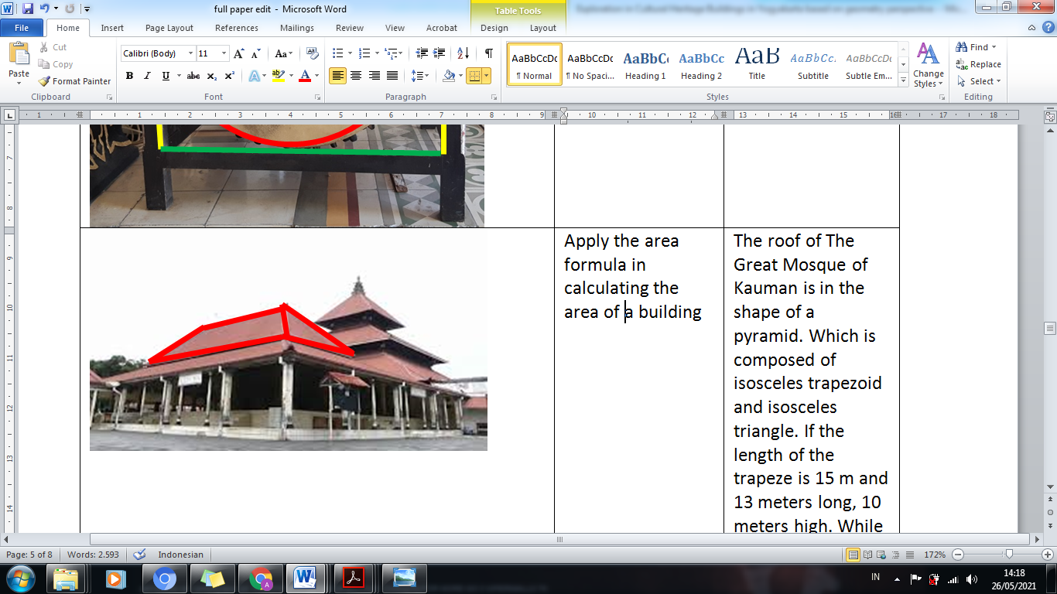 | Calculates the surface area of 3 dimensional shapes
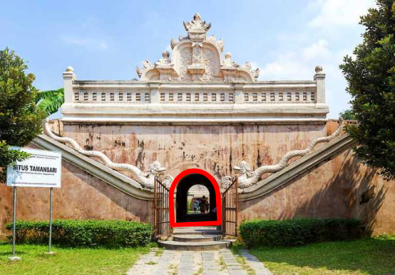 | Solve problems about the area of ​ rectangle and circle
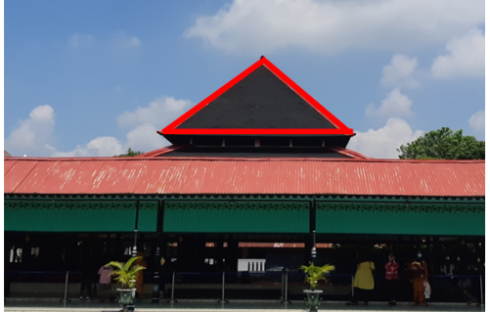 | Calculates the volume of 3 dimensional shapes
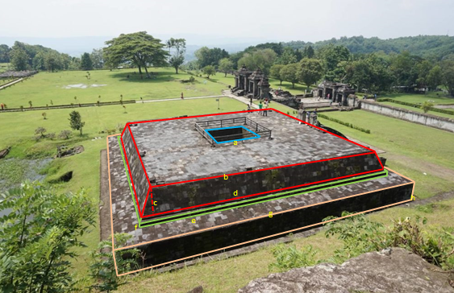 | Calculates the volume of 3 dimensional shapes
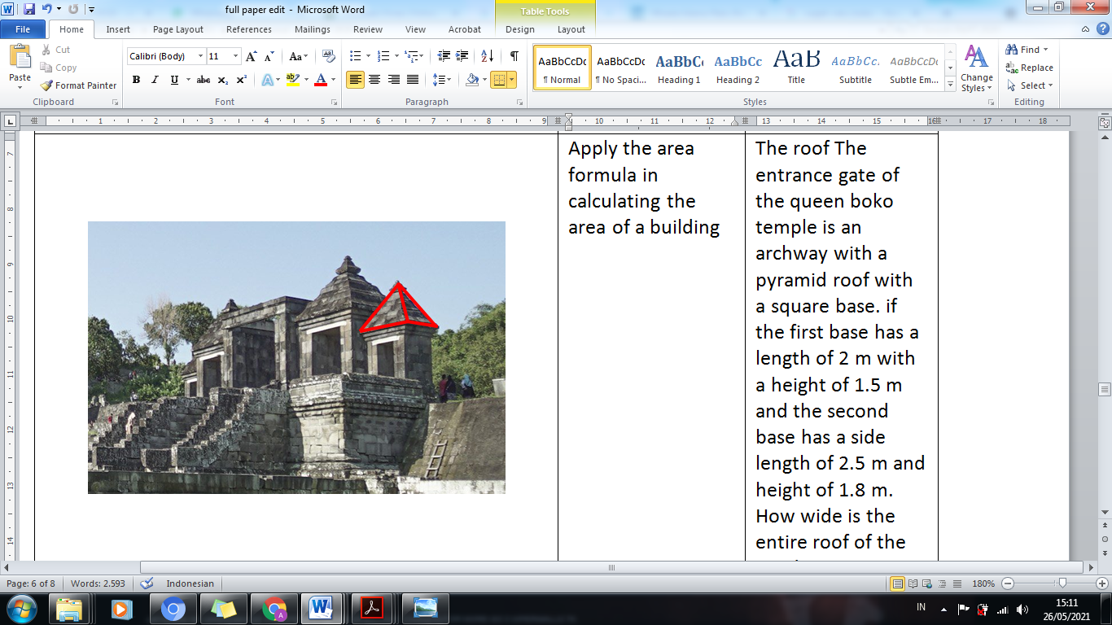 | Calculates the surface area of 3 dimensional shapes
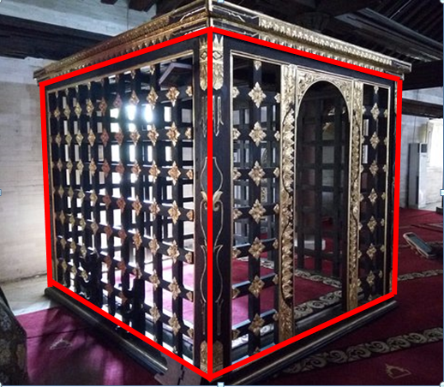 | Determine the diagonal length of the room

researchers use open source tools such as Unity Version 2019.1.14f1 which can be downloaded via the unity website in the developer tools section, as the main framework for building AR applications. Unity is software that is often used to create applications on various platforms, either console, desktop, or mobile. The second application tool is Vuforia which functions to store markers into the Vuforia SDK which later the marker will display the results of 3D objects that have been created through Blender because they are free without having to use a license(Atmajaya, 2017).
Design Stage
The process flow of the developed AR application can be seen in the flowchart of Figure 1. The first stage begins with the creation of an ethnomathematical 3D object that is in accordance with the SMP material. After the 3D object is finished, the object is imported into Unity which will later be used as an object to be used. appears and is matched with an existing marker.
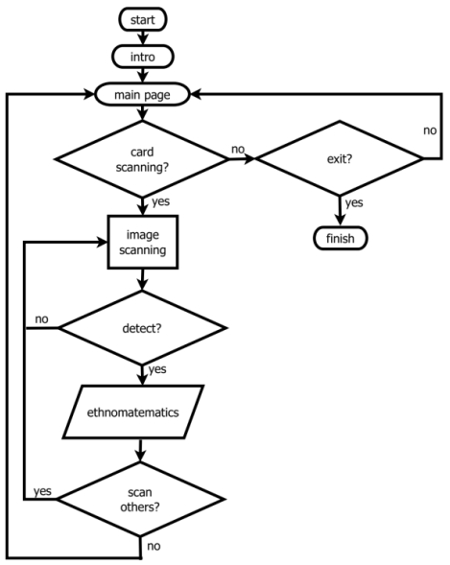
Fig. 1. AR Application Flowchart
The Use Case Diagram of the AR Application, as follows:

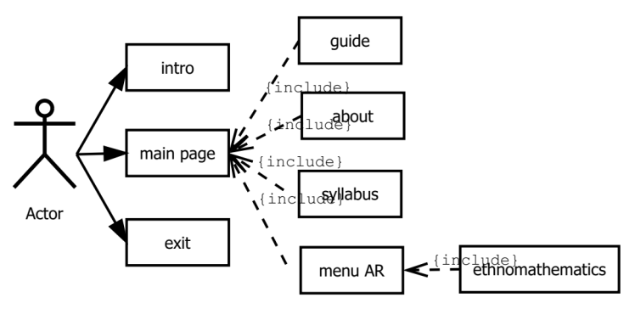
Fig. 2. AR Application Use Case Diagram
Figure 2. shows the use case diagram design in an AR application. Users just point the smartphone camera at the object. When the focus on the object is correct, the 3D object will appear on the screen, followed by information in the form of running text and audio according to the object selected by the user. The main interface design when the AR application is run has three main buttons in the initial view, namely: an introduction button containing information about the application and a summary of the material. menu button contains application usage guide, about (application name and author), syllabus, and AR menu. exit button to exit the AR program. Here's an initial view of the AR application;
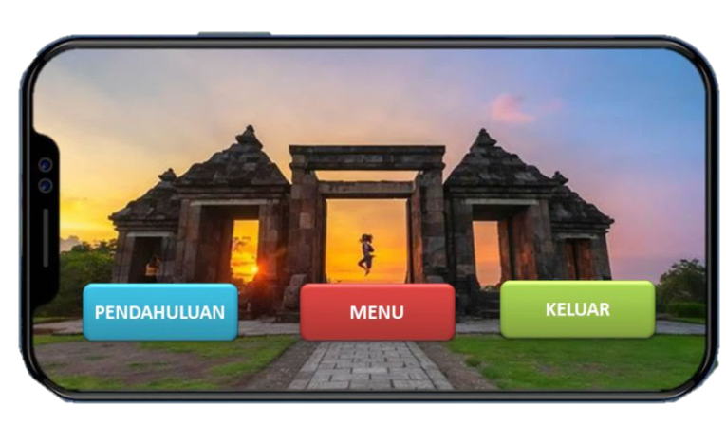
Fig. 3. AR App Initial View

Development Stage
In this section, the concept of a prototype design and development of the AR program will be explained with an ethnomathematical approach to geometry at the junior high school level. In this discussion will be divided into several parts as follows;
System Function
Based on Figure 4, it can be seen the running flow of the developed AR application. First, the user directs the marker object to the back camera of the cellphone. Then a 3D object will appear on the screen of the device used.
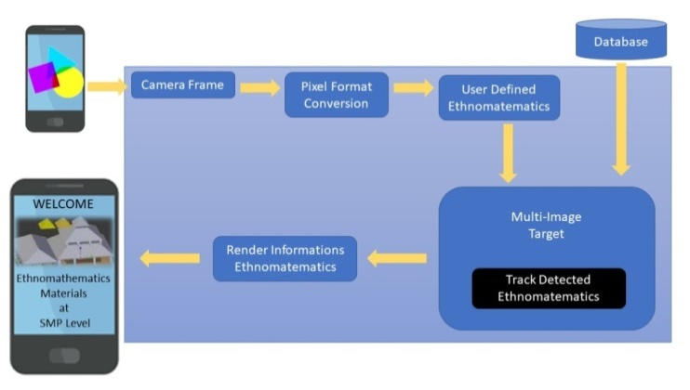
Fig. 4. Arsitektur Aplikasi AR

Marker Reading Process
In the prototype of this application, the user will get a marker / marker in the form of an image, then the marker is directed at the camera from the device used, a 3D object will appear on the user's device screen according to the selected marker object.
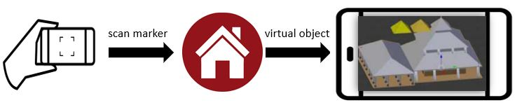
Fig. 5. Konsep prototipe aplikasi AR

The marker design developed is in the form of a Student Worksheet which contains a collection of several markers, learning materials, and evaluations. In the design of this student worksheet, an explanation of information from the marker object is included, for example for the Ratu Boko temple marker, information related to Ratu Boko Temple is explained which includes history, location, and most importantly the mathematical concepts contained in it according to the material studied by students. The function of student worksheets, apart from being a marker for AR applications, also serves as a medium to bring students to mathematical concepts with an experimental learning model. Because the design of the student worksheets also includes steps towards mathematical concepts and improves students' critical thinking skills(Abdullah, Shanti, & Sholihah, 2019).

Implementation Stage
The implementation of the AR Application prototype with an ethnomathematical approach for geometry material for Junior High Schools was carried out at MTs As Syalafiyah Mlangi, Sleman, Yogyakarta which was used as an example, the student responses that were obtained were quite good. In fact, students are more enthusiastic in using AR applications as a medium for learning mathematics with a cultural approach compared to conventionally taught classes. In addition, the interactions that occur between teachers and students are quite interesting. Observations made during the implementation of this AR application prototype, showed the excitement of students during the geometry learning process in class. As for the operation process, students did not experience problems and found it very easy, this was shown by the lack of user complaints that occurred during the testing process of the AR application prototype.

CONCLUSION
This paper concludes that android-based mathematics learning media using augmented reality technology with an ethnomathematical approach greatly motivates students in understanding geometric concepts compared to students taught by conventional learning. In addition, students are getting to know the cultural values that are located around students.

ACKNOWLEDGMENTS

The author expresses his gratitude to the Ministry of Education, Culture and Higher Education (KEMNDIKBUD DIKTI) the Republic of Indonesia for the grant that has been given to the "Penelitian Kerjasama Antar Perguruan Tinggi (PKPT)" scheme between Alma Ata University Indonesia and Yogyakarta State University Indonesia.

REFERENCES
Abdullah, A. A., Shanti, W. N., & Sholihah, D. A. (2019). Critical Thinking Ability Development Students Through Experiential Learning In The Calculus Class. IOP-J Series, 0.
Aditya, F., Trisno, B., Nurwijayanti, A., & Fitriana, L. (2018). The Use of Geometry Learning Media Based on Augmented Reality for Junior High School Students The Use of Geometry Learning Media Based on Augmented Reality for Junior High School Students. IOP Conf. Series: Materials Science and Engineering, 1–7. https://doi.org/10.1088/1757-899X/306/1/012029
Atmajaya, D. (2017). IMPLEMENTASI AUGMENTED REALITY UNTUK. ILKOM Jurnal Ilmiah Volume, 9(2), 227–232.
Fauzy, A., & Nurfauziah, P. (2021). Kesulitan Pembelajaran Daring Matematika Pada Masa Pandemi COVID- 19 di SMP Muslimin Cililin. Jurnal Cendekia: Jurnal Pendidikan Matematika, 05(01), 551–561.
Haji, S. (2018). Analisis Kesulitan Siswa dalam Menyesaikan Soal-Soal PISA ( Programme for International Student Assessment ) di SMP Kota Bengkulu. Jurnal Pendidikan Matematika Raflesia, 03(02), 177–183.
Handayani, S. D., & Irawan, A. (2020). Pembelajaran matematika di masa pandemic covid-19 berdasarkan pendekatan matematika realistik. Jurnal Math Educator Nusantara, 6(2), 179–189.
Johar, R. (2012). Domain Soal PISA untuk Literasi Matematika. Jurnal Peluang, 1(1), 30–41.
Mustaqim, I. (2016). PEMANFAATAN AUGMENTED REALITY SEBAGAI MEDIA PEMBELAJARAN. Jurnal Pendidikan Teknologi Dan Kejuruan, 13(2), 174–183.
Mustaqim, I., Pd, S. T., & Kurniawan, N. (2017). AUGMENTED REALITY. Jurnal Edukasi Elektro, 1(1), 36–48.
OCDE. (2019). PISA 2018 Results (volume i): what students know and can do. Paris: OECD Publishing.
Richardo, R., Martyanti, A., & Suhartini. (2019). Developing ethnomathematical tasks in the context of yogyakarta to measure critical thinking ability. Journal of Physics: Conference Series, 1188(1). https://doi.org/10.1088/1742-6596/1188/1/012063
Safitri, P. T., Yasintasari, E., Putri, S. A., & Hasanah, U. (2020). Analisis Kemampuan Metakognisi Siswa dalam Memecahkan Masalah Matematika Model PISA. Journal of Medives : Journal of Mathematics Education IKIP Veteran Semarang, 4(1), 11. https://doi.org/10.31331/medivesveteran.v4i1.941
Stacey, K. (2011). The PISA view of mathematical literacy in Indonesia. Journal on Mathematics Education, 2(2), 95–126. https://doi.org/10.22342/jme.2.2.746.95-126
Sudirman, Poppy Yaniawati, Mellawaty, R. I. (2021). Augmented reality application : What are the constraints and perceptions of the students during the covid 19 pendemic ’ s 3D geometry learning process ? Augmented reality application : What are the constraints and perceptions of the students during the co. Journal of Physics: Conference Series, 1783(012007), 1–7. https://doi.org/10.1088/1742-6596/1783/1/012007
W Widada, D Herawaty, K. U. Z. N. and A. F. D. A. (2021). Augmented Reality assisted by GeoGebra 3-D for geometry learning Augmented Reality assisted by GeoGebra 3-D for geometry learning. Journal of Physics: Conference Series, 1731(012934), 1–10. https://doi.org/10.1088/1742-6596/1731/1/012034

Universitas Alma Ata, Yogyakarta, Indonesia Email: ahmad.anis@almaata.ac.id.
Universitas Alma Ata, Yogyakarta, Indonesia Email: trirochmadi@almaata.ac.id.
Universitas Alma Ata, Yogyakarta, Indonesia Email: rinorichardo@almaata.ac.id.
Universitas Negeri Yogyakarta, Indonesia Email: nurkhamid@uny.ac.id.
Universitas Negeri Yogyakarta, Indonesia Email: a.wijaya@uny.ac.id.

