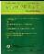
Contents list available at Directory of Open Access Journals (DOAJ)
Al-Ishlah: Jurnal Pendidikan
ISSN: 2087-9490 (Printed); 2597-940X (Online)
Journal Homepage: http://www.journal.staihubbulwathan.id/index.php/alishlah

The Concept of Law in the Academic Community during the Covid-19 Pandemic

Yusuf Faisal Ali
DOI: xxx

Article Info Abstract

Keywords:
Technology;
Communicatio; Rule of
Law; Covid-19

Kata kunci:
Technology;
Communicatio; Rule of
Law; Covid-19

Education, in the concept of rule of law for students during the pandemic still requires various efforts to foster an active participation of students. Education can be carried out by optimizing communication technology in the division during the Covid 19 pandemic. This study was descriptive research with a qualitative approach as methods. The study was conducted through interview, observation, literature studies, and documentation. The study has resulted some findings: 1) communication technology as a vehicle for education in the concept of a rule of law in the academic community during the pandemic purposed to teach students about rights and obligations as good citizens, 2) the campus had a role to provide the concept of a law state through student campus activity programs, and 3) a way out to deal with educational obstacles was that the concept of a rule of law during a pandemic was to improve the quality of programs during learning within the Covid 19 pandemic.

Abstrak

Education, in the concept of rule of law for students during the pandemic still requires various efforts to foster an active participation of students. Education can be carried out by optimizing communication technology in the division during the Covid 19 pandemic. This study was descriptive research with a qualitative approach as methods. The study was conducted through interview, observation, literature studies, and documentation. The study has resulted some findings: 1) communication technology as a vehicle for education in the concept of a rule of law in the academic community during the pandemic purposed to teach students about rights and obligations as good citizens, 2) the campus had a role to provide the concept of a law state through student campus activity programs, and 3) a way out to deal with educational obstacles was that the concept of a rule of law during a pandemic was to improve the quality of programs during learning within the Covid 19 pandemic.

Pendidikan Pancasila dan Kewarganegaraan
STKIP Pasundan Cimahi, Jawa Barat
yusuffaisalali2016@gmail.com

Vol.xxx August, 2021
Received: xxx; Received in revised form: xxx, 2021; Accepted: xxx, 2021; Available online: xxx, 2021 This is an open access article under a Creative Commons Attribution-NonCommercial-ShareAlike 4.0 International License

INTRODUCTION

The Covid-19 has transformed communication technology to encourage changes in various aspects of learning. Kar et al (2020) explain that the Covid-19 Pandemic has affected human life globally. In addition, the pandemic has also changed the way of delivery around the world(Darras et al., 2020). In this regard, practical learning requires any innovation within the process, especially in learning the concept of rule of law.

In terms of the practice of a democratic country like Indonesia, the concept of rule of law is one of the pillars in Character Education for legal awareness in Indonesia. The concept of rule of Law Education can be an institution for students’ involvement(Hidayah, 2020). The rule of Law Education concept can show that the law must be interpreted(Elliott, 2015). In the practice of a deep democratic state, this concept purposes to obtain and implement law education policies for the community.

However, the practice of this concept during the Covid-19 Pandemic has encountered many obstacles. Some evidences in Indonesia have shown some difficulties in implementing the rule of Law Education concept, namely:

The construction of Law Education is closely related to the right upon information during the pandemic. (Christianto, 2020)

The pandemic reminds us that learning is not only in the classroom, but also at home and many supporting places. (Rochmani, 2020)

In terms of law enforcement, the government must prepare further scenarios in handling Covid-19, especially to anticipate the predicted increase in the number of infections. Besides, the law must also be well-enforced when handling it in order that it can help to prevent a similar outbreak. (Ramadayanti, 2020)

There are many characteristics of law change during the pandemic, especially New Habits. (Andi, 2020)

New legal rules will be used to regulate life after the Covid-19 Pandemic (Suryono, 2020).

Based on the phenomenon concerning data and facts of the difficulty of implementing Law Education during the Covid-19 pandemic in Indonesia context, it is necessary to make efforts to optimize communication technology as a vehicle for education in the concept of rule of law for academic community. This is in line with Rajkovi's statement (2010) that the highest constitutional rule spreads normative standards that are conducive for dominant state power.

Based on the Indonesian Information and Communication Technology Development Index (IP-TIK), the use of communication technology in Indonesia in 2016 has reached 4.34 (scale 1 to 10) from 3.88 in the previous year. In addition, in Indonesia, the population of smartphone users has experienced a significant increase.
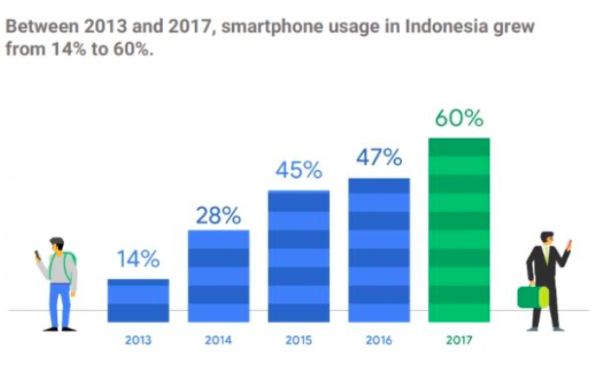
Figure 1. Growth of Smartphone Users in Indonesia
Source: (Edwin, 2017)

Regarding the current situation of implementing the concept of rule of Law Education during the pandemic, High School of Teacher Training and Education (STKIP) is one of the tertiary institutions in Cimahi City that carries out the activities of the Law State Concept Education course in the Department of Pancasila and Citizenship Education. The institute supports the steps taken by the government in developing the optimization of communication technology as a vehicle for education in the concept of rule of law in the academic community during the pandemic.

Based on the previous background, the study highlighted the optimization of communication technology as a vehicle for education in the concept of a rule of law in the academic community during the Covid-19 pandemic in the context of STKIP Pasundan Cimahi.

Methods

This study used a qualitative case study approach to dig deep information about the optimization of communication technology as a vehicle for education in the concept of a rule of law in the academic community during the Covid-19 pandemic. Moleong (2007) states that a qualitative approach is a research procedure that produces descriptive data in the form of written words. Data collection techniques which include interviews, literature study and documentation.

FINDINGS AND DISCUSSION

Based on the research, this study has obtained several results. First, communication technology as a vehicle for education in the concept of a rule of law in the academic community during the pandemic was to teach students about rights and obligations as good citizens. Second, the campus has a role to involve the concept of a law state through students’ campus activity programs. Third, a way out to deal with educational obstacles, the concept of a rule of law during the pandemic was to improve the quality of programs during learning.

Based on the results of interview, the study indicated that the optimization of communication technology as a vehicle for education in the concept of the rule of law in the academic community during the Covid-19 pandemic purposed to teach students about their rights and obligations as a good citizen. This finding is supported by a study’s finding that teaching students about their rights and obligations is one of the tasks given at every level of education (Ali, 2017). Besides, the optimization of communication technology is also in line with the analysis of technology needs that information and communication technology (ICT) is currently being prepared for the community based on cutting-edge research in industrial laboratories (Lahlou, 2008).

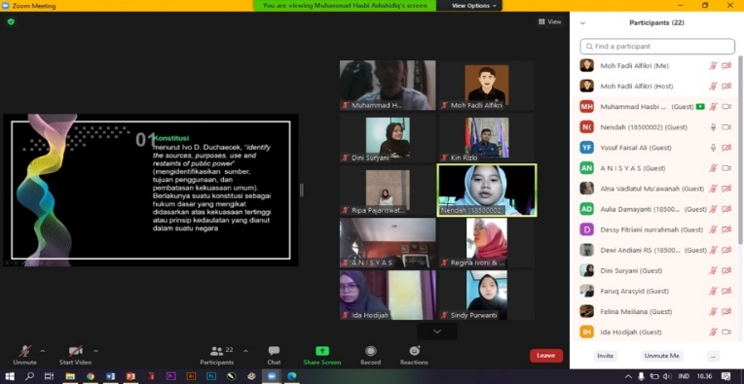
Figure 2. Online Learning through Zoom Meeting

This study also showed that communication technology emphasizes the theory and principles of the rule of law. These findings are similar to Skaaning's opinion (2009) that in many cases, the task of conceptualization is not based on theory, so that the main principles of the rule of law are sometimes ignored. However, the students at STKIP Pasundan Cimahi had obeyed all existing regulations during the pandemic.

Principally, techno-pedagogy theoretically supports the integration of technology in learning (Lawrence et al. 2020). Thus, the optimization of communication technology in this study was leading to the tendency for technology needs that the rapid development of information and communication technology has caused the internet and social media to become important platforms for public participation (Zhao et al, 2017).

In the context of STKIP Pasundan, teaching students about their rights and obligations as good citizens during the Covid-19 pandemic was seen as a strategy to emphasize their role in providing the concept of the state of law through students’ campus activity program. In socio-cultural context, technological developments and digital culture cannot be separated one another(Jin, 2017). Therefore, to emphasize the role of the campus, the STKIP Pasundan has provided a student activity unit that can be used as learning medium for students to understand the concept of the rule of law.
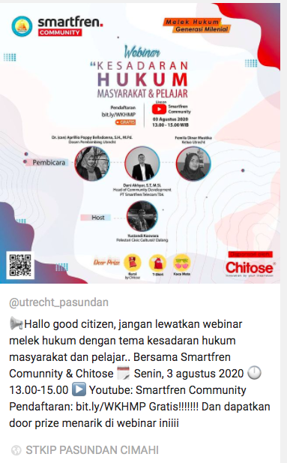
Figure 3. Activities of Students at UKM UTRECHT SKIP Pasundan Cimahi
Regarding Legal Awareness during the Covid-19 Pandemic
Source: Instagram UKM UTRECHT
Another results obtained from the interview was that the optimization of communication technology as a vehicle for education at STKIP Pasundan also had a global nuance that the concept of an opened society within the framework of an interdependent global conglomerate of nations, has created new challenges that can only be resolved in a global context (Zassoursk, 2002).
The theoretical perspective holds that knowledge transfer may not represent the best choice of workers due to some concerns about losing knowledge suitability (Law, 2013). Therefore, education in the concept of rule of law at STKIP Pasundan is also strengthened by the provision of Citizenship Education course to reinforce the concept of a rule of law for students.
The presented hardware and software platforms has enabled smart technology design (Torah et al., 2019). For students, optimizing communication technology in the subject of the rule of law concept is to prevent them from misunderstanding the concept of the legal state in general and in the context of STKIP Pasundan.
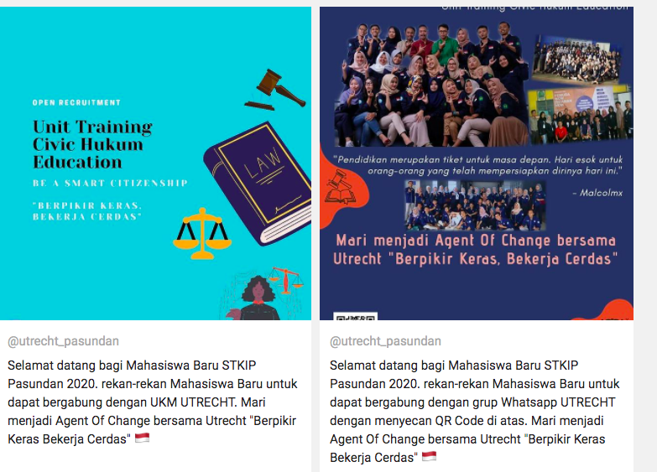
Figure 4. Activities of Students at UKM UTRECHT STKIP Pasundan Cimahi
Source: Instagram UKM UTRECHT
Based on the results of interview with informants, the optimization of communication technology as a vehicle for education in the concept of the rule of law in the academic community during the Covid-19 pandemic at STKIP Pasundan was considered as a way out in facing educational obstacles The concept of a rule of law during the pandemic was to improve the quality of programs during learning process. The benevolence of the rule of law is expected from judicial decision makers to enter administrative, executive decision-making party, and to advance rule of law projects (Thompson, 2019).
In the future, the work environment is recommended to integrate each individual (Broberg, 2000). Therefore, the rule of law education concept at STKIP Pasundan was to prioritize their professionalism as prospective teachers of Pancasila and Citizenship Education (PPKn) in Indonesia. Integrating the work environment with technology for students at the institute was implemented to realize regular, conducive learning and achieve goals.
The optimization of communication technology as a vehicle for education in the concept of the rule of law in the academic community during the Covid-19 pandemic at STKIP Pasundan was a part of awakening students, so that they could be aware of the effects of prevailing technology in their environment. Similar to this, Saxena et al state (2020) that technology has influenced every aspect of human life. In this context, student awareness is processed and obtained from citizenship knowledge (Trihastuti et al. 2020). Thus, it is clear that students at STKIP Pasundan got any benefit from the optimization of communication technology in the concept of the rule of law for students, where they must be able to obey any existing regulation.
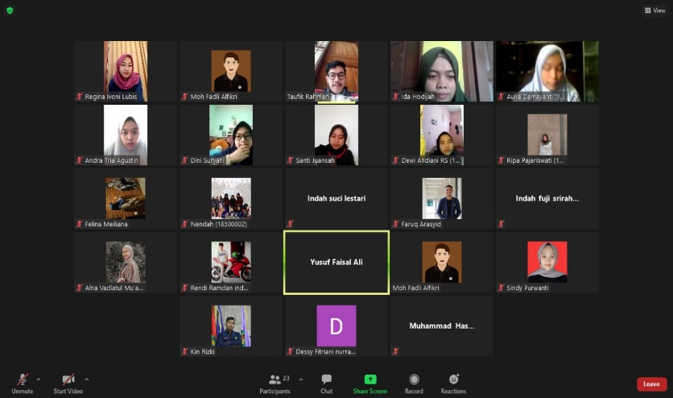
Figure 5. Online Learning through Zoom Meeting

Strictly speaking, teachers also have a role in learning (Fauzi & Ali, 2017). The optimization of communication technology in the subject Rule of Law Concept at STKIP Pasundan had led to emphasize the importance of knowing the concept of the rule of law for Pancasila and Citizenship Education (PPKn) prospective teachers in Indonesia to create a reliable teaching profession in Indonesia's pluralistic society, because teaching condition is related to teachers’ job satisfaction (Arnup & Bowles, 2016).
Teacher education is to educate the nation's teachers (Immig & Immig, 2006). Therefore, one of the efforts to instil the concept of a rule of law for Pancasila and Citizenship Education (PPKn) prospective teachers in Indonesia is to provide legal education integrated into Citizenship Education course, because education can support or hinder the enculturation of educational practice (Ståhle & Aspán, 2019). On the other hand, policy making in the field of education is an important part to manage the future (Forssell, 2015). As a prospective teacher for Pancasila and Citizenship Education (PPKn) in Indonesia, the rule of law concept has provided a great influence on the process of disseminating civics knowledge for them.
A board of knowledge on the concept of a rule of law for prospective teachers of Pancasila and Citizenship Education (PPKn) at STKIP Pasundan was obtained from habituation, so that when they attended as PPKn teachers, they have already known about the rule of law concept. Therefore, it results variety of changes in educational teaching practices (Miller et al., 2016). Besides, the university administrator as an integrated party has considered to re-organize academic life inside and outside the institution (Muthanna, 2015). Then, a number of efforts to impart knowledge for Pancasila and Citizenship Education (PPKn) prospective teachers at STKIP Pasundan have been implemented, particularly in providing education that can maximize their profession. Hence, there is a social impact on current issues and future directions in education planning (Jiang, Zhang, & Xin, 2018).

CONCLUSION

Based on these findings, this study can indicate three points. First, the communication technology as a vehicle for education in the concept of the rule of law in the academic community at STKIP Pasundan Cimahi during the pandemic has taught students about their rights and obligations as good citizens, so that the students can understand their role as citizens. Second, the campus (institute) has a role to provide the concept of the State of Law through students’ campus activity program. Third, in the way out in facing educational obstacles, the concept of the rule of law during the pandemic is to improve the quality of the program during learning process in the midst of the pandemic. In addition, optimizing communication technology as a vehicle for the concept of rule of law education in the academic community STKIP Pasundan has become a strategic step in Citizenship Education.

REFERENCES

- Ali, Y. F. (2017). UPAYA TOKOH AGAMA DALAM MENGEMBANGKAN SIKAP TOLERANSI ANTARUMAT BERAGAMA. Untirta Civic Education Journal, 17(2), 91–112.
- Andi, F. (2020). Great Reset Hukum di Masa Pandemi. Kompas.Com. Retrieved from https://www.kompas.com/tren/read/2020/08/21/152655765/great-reset-hukum-di-masa-pandemi?page=all
- Arnup, J., & Bowles, T. (2016). Should I stay or should I go? Resilience as a protective factor for teachers’ intention to leave the teaching profession. Australian Journal of Education, 60(3), 229–244. https://doi.org/10.1177/0004944116667620
- Broberg, O. (2000). Design of New Food Technology: Social Shaping of Working Environment. Proceedings of the Human Factors and Ergonomics Society Annual Meeting, 44(8), 16–19. https://doi.org/10.1177/154193120004400804
- Christianto, H. (2020). Penggunaan Media Internet dalam Pemenuhan Hak atas Pendidikan di Masa Pandemi Covid-19: Perspektif Hak Asasi Manusia dan Hukum Pidana. Jurnal HAM, 11(2). https://doi.org/10.30641/ham.2020.11.239-253
- Darras, K. E., Spouge, R. J., de Bruin, A. B. H., Sedlic, A., Hague, C., & Forster, B. B. (2020). Undergraduate Radiology Education During the COVID-19 Pandemic: A Review of Teaching and Learning Strategies. Canadian Association of Radiologists Journal, 0846537120944821. https://doi.org/10.1177/0846537120944821
- Edwin, Y. (2017). 10 Fakta pengguna internet di Indonesia dan dunia. Beritagar.Id.
- Elliott, C. (2015). Interpreting the Contours of Self-Defence within the Boundaries of the Rule of Law, the Common Law and Human Rights. The Journal of Criminal Law, 79(5), 330–343. https://doi.org/10.1177/0022018315603591
- Fauzi, W. I., & Ali, Y. F. (2017). ALAM BERKEMBANG MENJADI GURU (Nilai-Nilai Kehidupan Buya Hamka sebagai Sumber Pembelajaran Nilai di IPS). SOSIO DIDAKTIKA: Social Science Education Journal, 4(2). https://doi.org/10.15408/sd.v4i2.7991
- Forssell, A. (2015). School and the future: How teachers and teacher education are articulated in the political debate. Policy Futures in Education, 13(6), 712–731. https://doi.org/10.1177/1478210315595164
- Hidayah, Y. (2020). Thesis: PENGEMBANGAN MODEL BELAJAR KETERLIBATAN (MBK) UNTUK MEMPERKUAT PARTISIPASI POLITIK DAN CIVIC ENGAGEMENT WARGA NEGARA MUDA DI ERA DIGITAL. Bandung: Universitas Pendidikan Indonesia.
- Imig, D. G., & Imig, S. R. (2006). The Teacher Effectiveness Movement: How 80 Years of Essentialist Control Have Shaped the Teacher Education Profession. Journal of Teacher Education, 57(2), 167–180. https://doi.org/10.1177/0022487105285672
- Jiang, Y., Zhang, J., & Xin, T. (2018). Toward Education Quality Improvement in China: A Brief Overview of the National Assessment of Education Quality. Journal of Educational and Behavioral Statistics, 44(6), 733–751. https://doi.org/10.3102/1076998618809677
- Jin, D. Y. (2017). Construction of digital Korea: the evolution of new communication technologies in the 21st century. Media, Culture & Society, 39(5), 715–726. https://doi.org/10.1177/0163443717709441
- Kar, S. K., Dwivedi, S., Maurya, A. K., Singh, M., Kumar, R., Kumar, P., … Mallick, A. (2020). Enhancing Preparedness Among Frontline Doctors During COVID-19 Pandemic: Learning from Experience. Indian Journal of Psychological Medicine, 42(5), 489–491. https://doi.org/10.1177/0253717620952052
- Lahlou, S. (2008). Identity, social status, privacy and face-keeping in digital society. Social Science Information, 47(3), 299–330. https://doi.org/10.1177/0539018408092575
- Law, K. K. (2013). Managing Knowledge Transfer—A Communication-appropriation Perspective. Asia-Pacific Journal of Management Research and Innovation, 9(4), 359–367. https://doi.org/10.1177/2319510X14523103
- Lawrence, G., Ahmed, F., Cole, C., & Johnston, K. P. (2020). Not More Technology but More Effective Technology: Examining the State of Technology Integration in EAP Programmes. RELC Journal, 51(1), 101–116. https://doi.org/10.1177/0033688220907199
- Miller, A., Eather, N., Gray, S., Sproule, J., Williams, C., Gore, J., & Lubans, D. (2016). Can continuing professional development utilizing a game-centred approach improve the quality of physical education teaching delivered by generalist primary school teachers? European Physical Education Review, 23(2), 171–195. https://doi.org/10.1177/1356336X16642716
- Moleong, L. J. (2007). Metodologi Penelitian Kualitatif. Bandung: PT Remaja Rosdakarya.
- Muthanna, A. (2015). Quality education improvement: Yemen and the problem of the ‘brain drain.’ Policy Futures in Education, 13(1), 141–148. https://doi.org/10.1177/1478210314566734
- Rajkovic, N. M. (2010). ‘Global law’ and governmentality: Reconceptualizing the ‘rule of law’ as rule ‘through’ law. European Journal of International Relations, 18(1), 29–52. https://doi.org/10.1177/1354066110380966
- Ramadayanti, E. (2020). COVID-19 dalam Perspektif One Health Approach dan Law Enforcement. Fh.Unpad.Ac.Id. Retrieved from https://fh.unpad.ac.id/covid-19-dalam-perspektif-one-health-approach-dan-law-enforcement/
- Rochmani. (2020). PENDIDIKAN Di MASA PANDEMI COVID 19. Fh.Unisbank.Ac.Id.
- Saxena, C., Baber, H., & Kumar, P. (2020). Examining the Moderating Effect of Perceived Benefits of Maintaining Social Distance on E-learning Quality During COVID-19 Pandemic. Journal of Educational Technology Systems, 0047239520977798. https://doi.org/10.1177/0047239520977798
- Skaaning, S.-E. (2009). Measuring the Rule of Law. Political Research Quarterly, 63(2), 449–460. https://doi.org/10.1177/1065912909346745
- Ståhle, Y., & Aspán, M. (2019). Teacher Students’ Experienced Challenges in the Beginning of Their Education. Journal of Education, 199(1), 3–12. https://doi.org/10.1177/0022057419834913
- Suryono, K. E. (2020). Peranan Hukum Tata Negara dalam Pandemi Covid-19 dan Menuju ke Arah New Normal. Http://New.Widyamataram.Ac.Id/. Retrieved from http://new.widyamataram.ac.id/content/news/peranan-hukum-tata-negara-dalam-pandemi-covid-19-dan-menuju-ke-arah-new-normal#.X-liUukzZQI
- Thompson, K. (2019). The rule of law, arbitrariness and institutional virtue. Alternative Law Journal, 44(2), 159–163. https://doi.org/10.1177/1037969X19829850
- Torah, R., Wei, Y., Grabham, N., Li, Y., de Vos, M., Todorov, T., … Tudor, J. (2019). Enabling platform technology for smart fabric design and printing. Journal of Engineered Fibers and Fabrics, 14, 1558925019845903. https://doi.org/10.1177/1558925019845903
- Trihastuti, M., Dewie, D. A., & Hidayah, Y. (2020). Increasing Students’ Entrepreneurship Awareness through Citizenship Knowledge (A Study on Students at STKIP Pasundan Cimahi). American Journal of Multidisciplinary Research & Development (AJMRD), 2(9), 09–15.
- Zassoursky, Y. N. (2002). Media and Communications as the Vehicle of the Open Society: The Internet and the Global Society. Gazette (Leiden, Netherlands), 64(5), 425–432. https://doi.org/10.1177/17480485020640050301
- Zhao, M., Lin, Y., & Derudder, B. (2017). Demonstration of public participation and communication through social media in the network society within Shanghai. Environment and Planning B: Urban Analytics and City Science, 45(3), 529–547. https://doi.org/10.1177/2399808317690154

